CDDpress

www.nature.com/cddis

ARTICLE

OPEN



GATA zinc ﬁnger protein p66β promotes breast cancer cell migration by acting as a co-activator of Snail
Xiuqun Zou1,2,9, Li Ma3,9, Yihong Zhang1,2, Qun Zhang1,2, Chu Xu1,2, Dan Zhang 1,2, Yimin Chu4, Jie Zhang1,2, Mengying Li1,2, Hui Zhang1,2, Jiamin Wang1,2, Chicheng Peng5, Gang Wei 3, Yingjie Wu6 ✉, Zhaoyuan Hou 1,2,7,8 ✉ and Hao Jia 1,2 ✉
© The Author(s) 2023

The transcriptional repressor Snail induces EMT during embryonic development and tumor metastasis. Growing evidence indicates that Snail functions as a trans-activator to induce gene expression; however, the underlying mechanism remains elusive. Here, we report that Snail cooperates with GATA zinc ﬁnger protein p66β to transactivate genes in breast cancer cells. Biologically, depletion of p66β reduces cell migration and lung metastasis in BALB/c mice. Mechanistically, Snail interacts with p66β and cooperatively induces gene transcription. Notably, a group of genes induced by Snail harbor conserved G-rich cis-elements (5I-GGGAGG-3I,
designated as G-box) in their proximal promoter regions. Snail directly binds to G-box via its zinc ﬁngers and transactivates the G- box-containing promoters. p66β enhances Snail binding afﬁnity to G-box, whereas depletion of p66β results in a decreased binding afﬁnity of Snail to the endogenous promoters and concomitantly reduces the transcription of Snail-induced genes. Taken together, these data demonstrated that p66β is critical for Snail-mediated cell migration by acting as a co-activator of Snail to induce genes containing G-box elements in the promoters.
Cell Death and Disease (2023)14:382; https://doi.org/10.1038/s41419-023-05887-w

INTRODUCTION
The transcription factor Snail is a prominent inducer of the epithelial–mesenchymal transition (EMT) during embryonic devel- opment and cancer progression [1–5]. In many cancer cells, elevated Snail expression induces stem cell-like phenotypes accompanied by immune escape, chemoresistance, and metas- tasis [6–10]. These functions are mainly attributed to Snail as a potent transcriptional repressor that initiates the EMT program, as evidenced by the downregulation of various epithelial markers such as E-cadherin and Claudins [2, 11–13].
Snail represses gene transcription by relying on the cooperation of conserved tandem zinc ﬁnger motifs located at the C-terminus and the Snail/Gﬁ-1 (SNAG) domain at the N-terminus. Zinc ﬁngers speciﬁcally bind to E-box elements (5I-CANNTG-3I) residing in their target promoters, whereas the SNAG motif recruits multiple repressive complexes to silence gene transcription [14, 15]. These complexes include histone deacetylases, mSin3A, Suv39H1, LSD1, Ring1A/B, and Ajuba/Prmt5/14-3-3 ternary complexes, which are involved in histone modiﬁcations such as acetylation, methylation, and ubiquitination [16–22].
Notably, growing evidence indicates that Snail can transactivate gene expression directly, but distinct models are proposed to

explain the transactivation of Snail [23]. For example, Snail binds to the E-box-rich regions of ERCC1 and MMP15 promoters to induce their expression by a potential mechanism that Snail interacts with CBP to acetylate K146 and K187 residues, which results in preventing the formation of the repressor complex [24–26]. The Snail homolog CES-1 in C. elegans induces the expression of genes containing bHLH transcription factor binding elements and E-box elements [27]. Notably, new models suggest that transcriptional activation by Snail is dependent on novel transcriptional motifs or elements rather than the canonical E-box sequence. A novel Snail-responsive element (5I-TCACA-3I) was identiﬁed in the promoters of ZEB1, MMP9, and p15INK4b genes activated by Snail in collaboration with EGR-1 and SP-1 [28, 29]. p65NF-kB, PARP1, and Snail form multiple protein complexes at the Fibronectin 1 (FN) promoter to induce FN transcription [30]. In Drosophila Snail is also shown to induce the expression of genes critical for mesoderm development by collaborating with Twist [31]. Nevertheless, the exact mechanism by which Snail induces gene expression still remains elusive.
The p66α (GATAD2A) and p66β (GATAD2B) proteins are two members of the p66 family that contain a GATA zinc ﬁnger in conservative region two (CR2) in the C-terminal [32]. Classical

1Hongqiao Institute of Medicine, Tongren Hospital/Faculty of Basic Medicine, Shanghai Jiaotong University School of Medicine, Shanghai, China. 2Shanghai Key Laboratory for Tumor Microenvironment and Inlammation, Department of Biochemistry & Molecular Cellular Biology, Shanghai Jiaotong University School of Medicine, Shanghai, China. 3Key Laboratory of Computational Biology, CAS-MPG Partner Institute of Computational Biology, Shanghai Institute for Biological Science, Chinese Academy of Sciences, Shanghai, China. 4Digestive Endoscopy Center, Shanghai Tongren Hospital, Shanghai Jiaotong University School of Medicine, Shanghai, China. 5Naruiboen Biomedical Technology Corporation Limited, Linyi, Shandong, China. 6Shandong Provincial Hospital, Shandong Laboratory Animal Center, Science and Technology Innovation Center, Shandong First Medical University & Shandong Academy of Medical Sciences, Jinan, Shandong, China. 7Key Laboratory of Cell Differentiation and Apoptosis of Chinese Ministry of Education, Shanghai, China. 8Linyi University-Shanghai Jiaotong University Joint Institute of Translational Medicine, Linyi, Shandong, China. 9These authors contributed equally: Xiuqun Zou,
Li Ma. ✉email: yjwu@sdfmd.edu.cn; houzy@sjtu.edu.cn; fonney@sjtu.edu.cn
Edited by Professor Roberto Mantovani
Received: 29 August 2022 Revised: 15 May 2023 Accepted: 12 June 2023
I'ub lis bed online:28June2023
Ofﬁcial journal of CDDpress 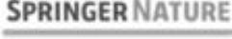
CDDpress

X. Zou et al.
2
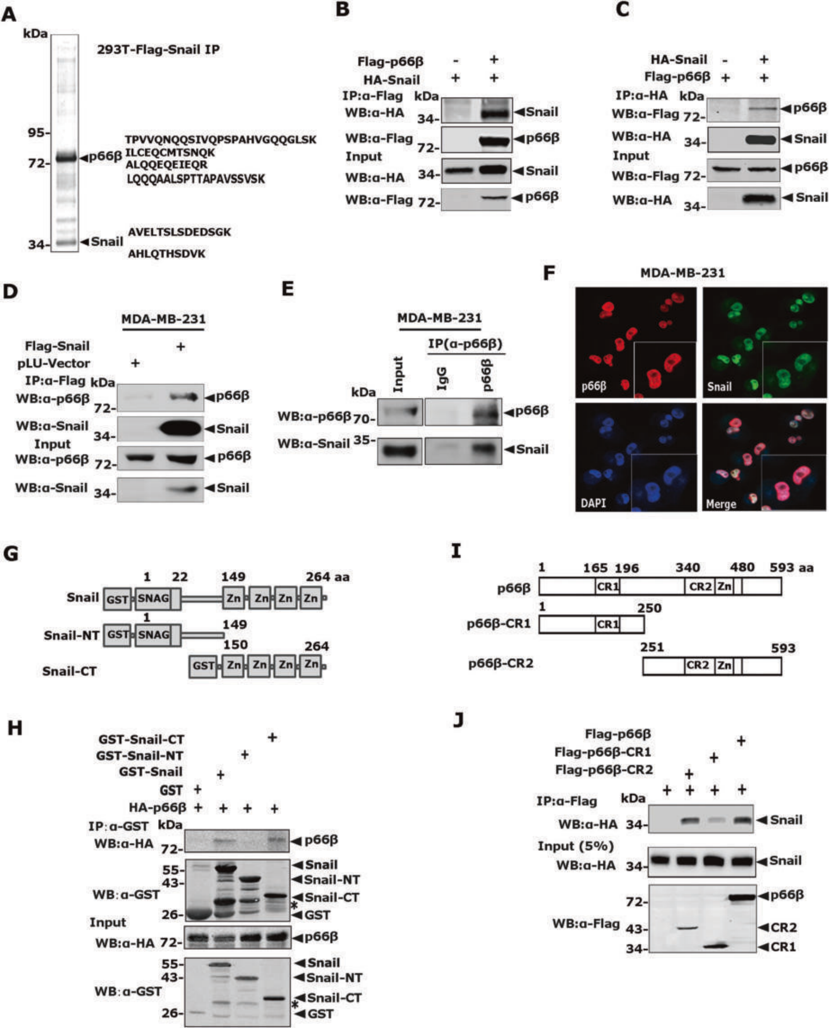

vertebrate GATA transcription factors have two zinc ﬁngers and comprise the general conﬁguration of Cys-X2-Cys-X17-Cys-X2-Cys. While the zinc ﬁnger in the C-terminal speciﬁcally recognizes the consensus sequence A/T(GATA)A/G in the target promoters, the N-terminal zinc ﬁnger predominantly interacts with partner proteins such as the FOG family proteins to stabilize the DNA- protein complex [33, 34]. However, the GATA zinc ﬁnger in p66α/

p66β has not been reported to be capable of binding to DNA or protein.
The p66 family was ﬁrst identiﬁed as a component of the highly conserved, ATP-dependent, and nucleosome remodeling and deacetylase (NuRD) complex that dominates a transcriptional repression process on methylated CpG islands depending on its nucleosome remodeling and deacetylation activity [35]. While the

SPRNGER NATURE Cell Death and Disease (2023)14:382

X. Zou et al.
3
Fig. 1 Snail binds the CR2 domain of p66β through its zinc ﬁnger motifs. A Colloidal staining showed that p66β was a potential Snail- interacting protein puriﬁed from HEK-293 cells. B, C Plasmids encoding Flag- p66β and HA- Snail were transiently transfected into HEK-293T cells, the cell lysates were incubated with either anti-Flag M2 beads or HA antibody and the co-eluted proteins were blotted with anti-HA (B) or anti-Flag (C) antibodies. α, anti; WB, Western blotting. D Snail interacted with p66β at the endogenous level. Lysates prepared from MDA- MB-231-Flag-Snail stable cells were incubated with anti-Flag M2 beads, and the co-eluted proteins were detected with an anti-p66β antibody. E Lysates prepared from MDA-MB-231 cells were incubated with an anti-p66β antibody and protein A/G beads, and the co-eluted proteins were detected with a Snail antibody. F Co-localization of Snail and p66β in MDA-MB-231 cells. Endogenous Snail and p66β in MDA-MB-231 cells were detected for immunoluorescence staining using anti-Snail and anti-p66β antibodies, and the images were taken by confocal microscopy. Scale bar: 90 μm. G Schematic diagrams showed full-length and truncated Snail proteins. H The C-terminal zinc ﬁngers of the Snail interacted with p66β . Bacterially expressed GST-Snail and its truncation proteins, together with HA-p66β proteins prepared from HEK- 293T cells were incubated with GST beads, and co-eluted proteins were analyzed by anti-HA. *non-speciﬁc band. I Schematic diagrams showed full-length and truncated forms of p66β. The CR2 domain contains a GATA-type zinc ﬁnger motif. J The CR2 domain of p66β interacted with Snail. Lysates prepared from HEK-293T cells transfected with plasmids encoding Flag-p66β and its truncation mutants, together with HA- Snail were incubated with anti-Flag M2 beads, and co-eluted proteins were analyzed by anti-HA.

CR1 domain of p66 mediates the interaction between p66 and other NuRD components, the CR2 domain of p66 is essential for targeting the NuRD complex to speciﬁc nuclear loci and for mediating histone tail interaction [32, 36]. Thus, p66β proteins are usually reported to exert transcriptional repression function as a component of the NuRD complex to participate in various functions, such as regulating progesterone receptor and neuro- developmental disorders [37, 38]. However, Grzeskowiak et al. reported that p66β induces Myc expression in KRAS-mutant lung cancer cells, indicating that p66β could function as a transcrip- tional activator [39].
In this study, we report that Snail interacts with the CR2 domain of p66β via its zinc ﬁnger. p66β and Snail transactive genes that are activated but not repressed by Snail contain a conserved G-rich cis-element (5I-GGGAGG-3I) in the proximal target promo- ter regions. Snail cooperates with p66β to transactivate gene transcription by binding to G-rich cis-elements within its target promoters.

RESULTS
Snail interacts with p66β
To identify molecules that can cooperate with Snail to promote metastasis, we established HEK-293T cells stably expressing Flag- Snail and performed afﬁnity puriﬁcation assays. The co-eluents were resolved by SDS-PAGE followed by silver staining, and the speciﬁc band at 66 kDa was identiﬁed as p66β (Fig. 1A). To conﬁrm the interaction between Snail and p66β, we co-expressed HA-Snail and Flag-p66β in HEK-293T cells and performed reciprocal co-IP assays. Indeed, Snail and p66β interacted with each other (Fig. 1B, C). Moreover, stably expressed Flag-Snail co-immunoprecipitated with the endogenous p66β protein (Fig. 1D). Reciprocally, p66β immunoprecipitated with Snail endogenously (Fig. 1E). To determine the subcellular localization of Snail and p66β, indirect immunoluorescence assays were performed in MDA-MB-231 cells using antibodies speciﬁcally against Snail or p66β (Fig. 1F). Notably, both Snail and p66β proteins co-localized in the nucleus.
Snail binds the CR2 domain of p66β through its zinc ﬁnger region
To determine the regions in Snail responsible for p66β binding, full-length of GST-Snail, truncated zinc-ﬁnger structure (GST-Snail- CT), and SNAG domain (GST-Snail-NT) proteins were incubated with HA-p66β protein prepared from HEK-293T cells. The co- precipitation experiments were performed by using GST beads, and the co-eluted HA- p66β protein was examined by Western blotting assays using an anti-HA antibody. GST-Snail-CT and the full-length of GST-Snail showed similar binding afﬁnities to p66β, whereas GST-Snail-NT showed no binding (Fig. 1G, H).
To identify regions in p66β that are critical for the interaction between p66β and Snail, p66β full-length or truncations were transiently co-expressed with HA-Snail in HEK-293T cells. Co-IP

assays demonstrated that the CR2 domain displayed strong binding activity toward Snail, which was comparable to that of full-length p66β, whereas the CR1 domain showed weak binding activity (Fig. 1I, J). Taken together, these data indicated that p66β is a novel Snail-interacting protein and that its binding is mediated by the zinc ﬁnger region of Snail and the CR2 region of p66β.
p66β promotes breast cancer cell migration and metastasis To examine the potential function of p66β in breast cancer, we analyzed the expression of p66β, Snail, and EMT markers in breast cancer cells, and p66β was highly expressed in triple-negative cells (Fig. S1A). To determine the role of p66β in breast cancer cell migration, p66β was stably expressed in MCF-10A cells, and the resulting cells were subjected to transwell assays (Fig. 2A and Fig. S1B). Ectopic expression of p66β or CR2 truncation apparently enhanced the migratory ability of MCF-10A and MDA-MB-231 cells (Fig. 2B, C and Fig. S1E–G). Conversely, depletion of p66β resulted in a signiﬁcant decrease in the migratory abilities of SUM- 159 and MDA-MB-231 cells (Fig. 2D–I and Fig. S1C, D). More importantly, depletion of p66β in luciferase-labeled MDA-MB-231 cells greatly decreased lung colonization, as indicated by the lower luciferase intensity and fewer and smaller micro-metastatic nodules in BALB/c female nude mice, in which the resulting cells were injected via the tail vein (Fig. 2J–N). Collectively, these data demonstrated that p66β promotes breast cancer cell migration and metastasis.
p66β is required for Snail-mediated cell migration
To determine whether p66β is critical for Snail-mediated cell migration and metastasis, we depleted p66β in MDA-MB-231-Snail or -Vector cells, respectively (Fig. 3A). The transwell assays showed that depletion of p66β markedly dampened Snail-mediated cell migration (Fig. 3B, C). Notably, knockdown of Snail also decreased p66β-induced cell migration ability (Fig. S2). Moreover, we analyzed the Kaplan–Meier plotter database and found that high expression of Snail and p66β was predictive of poor prognosis in patients with triple-negative (ER-/PR-/HER2-) breast tumors, respectively (Fig. 3D, E).
Snail and p66β cooperatively induce target gene transcription To determine whether p66β participates in Snail-mediated gene transcription, we ﬁrst examined the best-known Snail target genes such as CDH1, FN, as well as PAPSS2, and COL6A2 which were induced by Snail in our previous RNA-seq analysis [40]. Neither ectopic expression nor depletion of p66β affected the mRNA level of CDH1. However, the expression of p66β apparently increased the mRNA levels of the PAPSS2, COL6A2, and FN genes (Fig. 4A, B), suggesting that p66β may participate in Snail-mediated gene induction rather than repression.
Next, the CDH1-Luc, PAPSS2-Luc, or COL6A2-Luc reporters, together with plasmids encoding Flag-p66β, were transiently transfected into HEK-293T cells, and the luciferase activity was

Cell Death and Disease (2023)14:382 SPRNGER NATURE

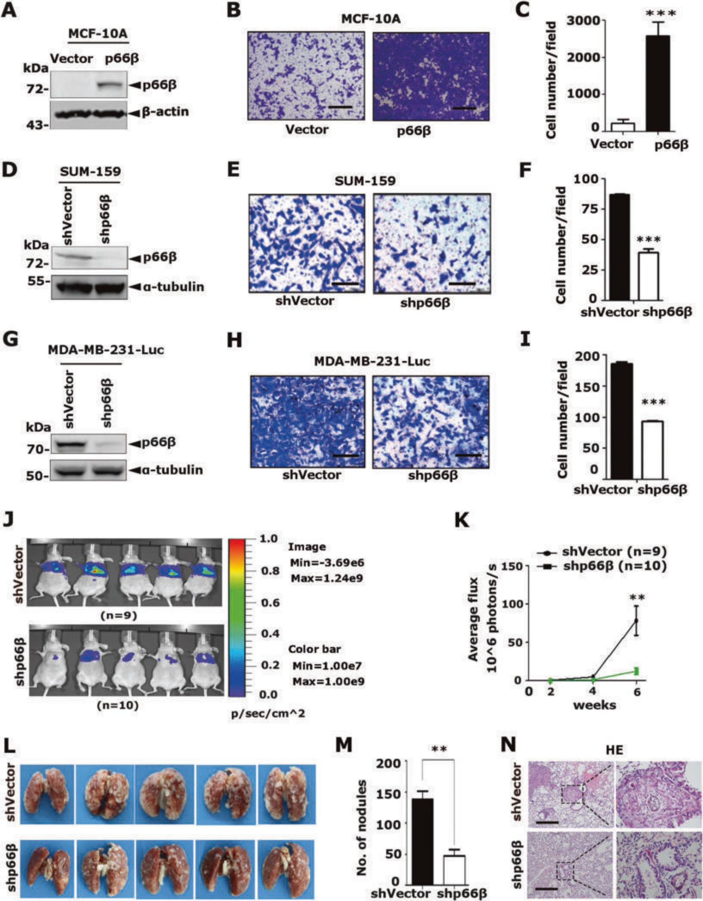
Fig. 2 p66β promotes breast cancer cell migration and metastasis. A–C Ectopic expression of p66β induced cell migration in MCF-10A cells by transwell assay (A). Images represent one microscopic ﬁeld in each group (B). Scale bar: 200 μm. Quantiﬁcation of migrated cells is shown (C) (n = 5 ﬁelds were randomly chosen and counted for statistical analysis). ***p < 0.001. D–F Depletion of p66β inhibited the migration of SUM-159 cells. Scale bar: 100 μm (n = 9 ﬁelds were randomly chosen and counted for statistical analysis). ***p < 0.001. G–I Depletion of p66β inhibited the migration of MDA-MB-231 cells. Scale bar: 100 μm (n = 9 ﬁelds were randomly chosen and counted for statistical analysis).
***p < 0.001. J, K MDA-MB-231-Luc cells stably expressing p66β shRNA or shVector were injected into the tail veins of female nude mice. The development of lung metastases was recorded on the 2nd, 4th, and 6th week using luciferase bioluminescence imaging and quantiﬁed by measuring the photon lux compared with the mock group (n = 9 and n = 10 mice, respectively). **p < 0.01. L, M Depletion of p66β decreased the number of metastatic lung nodules. **p < 0.01. N Lung metastatic nodules were detected in parafﬁn-embedded sections stained with hematoxylin and eosin. Images were taken at 10x magniﬁcation with a scale bar of 200 μm; images were taken at 40× magniﬁcation with a scale bar of 50 μm). All data are shown as the mean ± S.D. by Student’s t-test.

SPRNGER NATURE Cell Death and Disease (2023)14:382

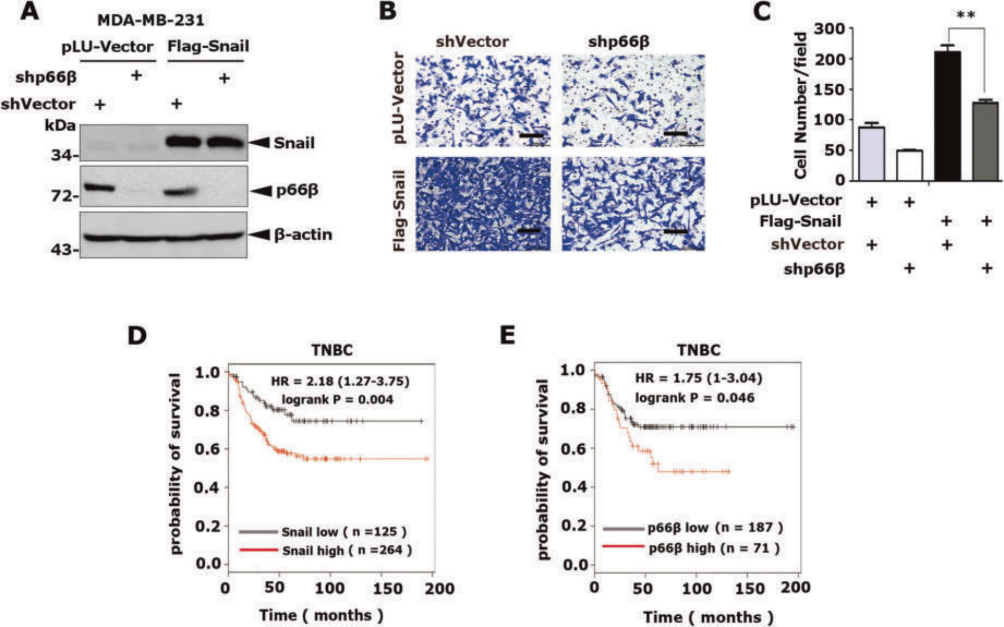
Fig. 3 p66β is required for Snail-mediated cell migration. A Depletion of p66β in Snail stably expressed MDA-MB-231 cells. Western blotting showing the protein levels of Snail and p66β . B Knockdown of p66β reduced the cell migration mediated by Snail. Scale bar: 100 μm. C Statistical analysis of the migrating cells from the transwell assays was shown in the bar graphs (n = 9 ﬁelds were randomly chosen and counted for statistical analysis). The data are shown as the mean ± S.D. by Student’s t-test. **p < 0.01. D, E Kaplan–Meier plots of the relapse- free survival of patients with triple-negative (ER-/PR-/HER2-) breast cancer (TNBC) in the whole data set stratiﬁed by Snail and p66β expression. Data were acquired from the Kaplan–Meier plotter database. The p-value for Kaplan–Meier curve was determined using a log-rank test, Statistical signiﬁcance was set at p < 0.05.

normalized to β-galactosidase activity. Consistently, p66β showed no effect on the CDH1-Luc reporter activity (Fig. 4C), but stimulated PAPSS2-Luc and COL6A2-Luc reporter activities in a dosage-dependent manner (Fig. 4D, E). Moreover, Snail alone inhibited CDH1 promoter activity, and adding p66β did not apparently affect the inhibitory effect of Snail (Fig. 4F). Conversely, Snail or p66β alone weakly or modestly induced PAPSS2-Luc and COL6A2-Luc activity, whereas co-expression of Snail and p66β markedly induced PAPSS2-Luc and COL6A2-Luc activity (Fig. 4G, H), indicating that p66β cooperates with Snail to induce target gene expression.
To explain the paradox that the NuRD transcriptional repression complex component p66β is involved in Snail-mediated transcrip- tional activation, Flag-p66β, HA-MTA2, and/or HA-Snail were co- expressed in HEK-293T cells and co-IP assays were performed. The co-eluted bands showed that MTA2 and Snail could be pull- downed by Flag-p66β, respectively. The interaction between p66β and MTA2 weakened with the increased expression of HA-Snail (Fig. S3), indicating that Snail competes with the MTA2 protein for p66β.
Snail-induced genes contain G-box elements in their proximal promoter regions
By analyzing the promoter sequences of Snail-induced genes, a conserved G-rich cis-element (5I-GGGAGG-3I, designated as G-box herein) was identiﬁed in their proximal promoter regions (Fig. 5A). To strengthen this observation, we analyzed the published ChIP-seq data of Snail binding sites in tumor cells prepared from MMTV-PyMT mice using RSAT software and identiﬁed 137 G-box sites where Snail displayed peak binding

activities (Fig. 5B and Fig. S4A, B) [8]. Among the 137 G-box sites, we selected 14 genes conserved in humans and mice and then examined their mRNA levels in human and mouse mammary cells that stably expressed Snail, respectively (Table 1). Indeed, Snail induced the expression of the selected representative genes (Fig. 5C and Fig. S4C). Conversely, depletion of Snail by using speciﬁc shRNAs decreased the mRNA levels of these genes (Fig. 5D). Notably, an antibody speciﬁc to Snail readily enriched the DNA fragments lanking the G-box elements in the representative promoters of JDP2, EMP3, COL6A2, and PAPSS2 examined by chromatin immunoprecipitation assays (Fig. 5E). Taken together, these data indicated that Snail can induce the transcription of genes containing G-box elements in their promoters and that the G-box element is a potential Snail- responsive element.
Snail induces transcriptional activity of promoter reporters driven by G-box element
To determine whether Snail directly modulates the activity of the G-box element, we ﬁrst mutated the G-box of PAPSS2-Luc. The two reporters, together with plasmids encoding HA-Snail, were transiently transfected into HEK-293T cells and showed four-fold Snail-induced PAPSS2-Luc reporter activity but had no effect on the mutant reporter (Fig. 6A left). Similarly, Snail induced the activity of the COL6A2-Luc reporter containing a G-box element, but not a mutant reporter (Fig. 6A right). Moreover, deletion of the SNAG domain of Snail did not obviously affect Snail-mediated induction of promoters with G-boxes (Fig. S5). These data demonstrated that Snail induces the transcriptional activity of promoters containing G-box elements.

Cell Death and Disease (2023)14:382 SPRNGER NATURE

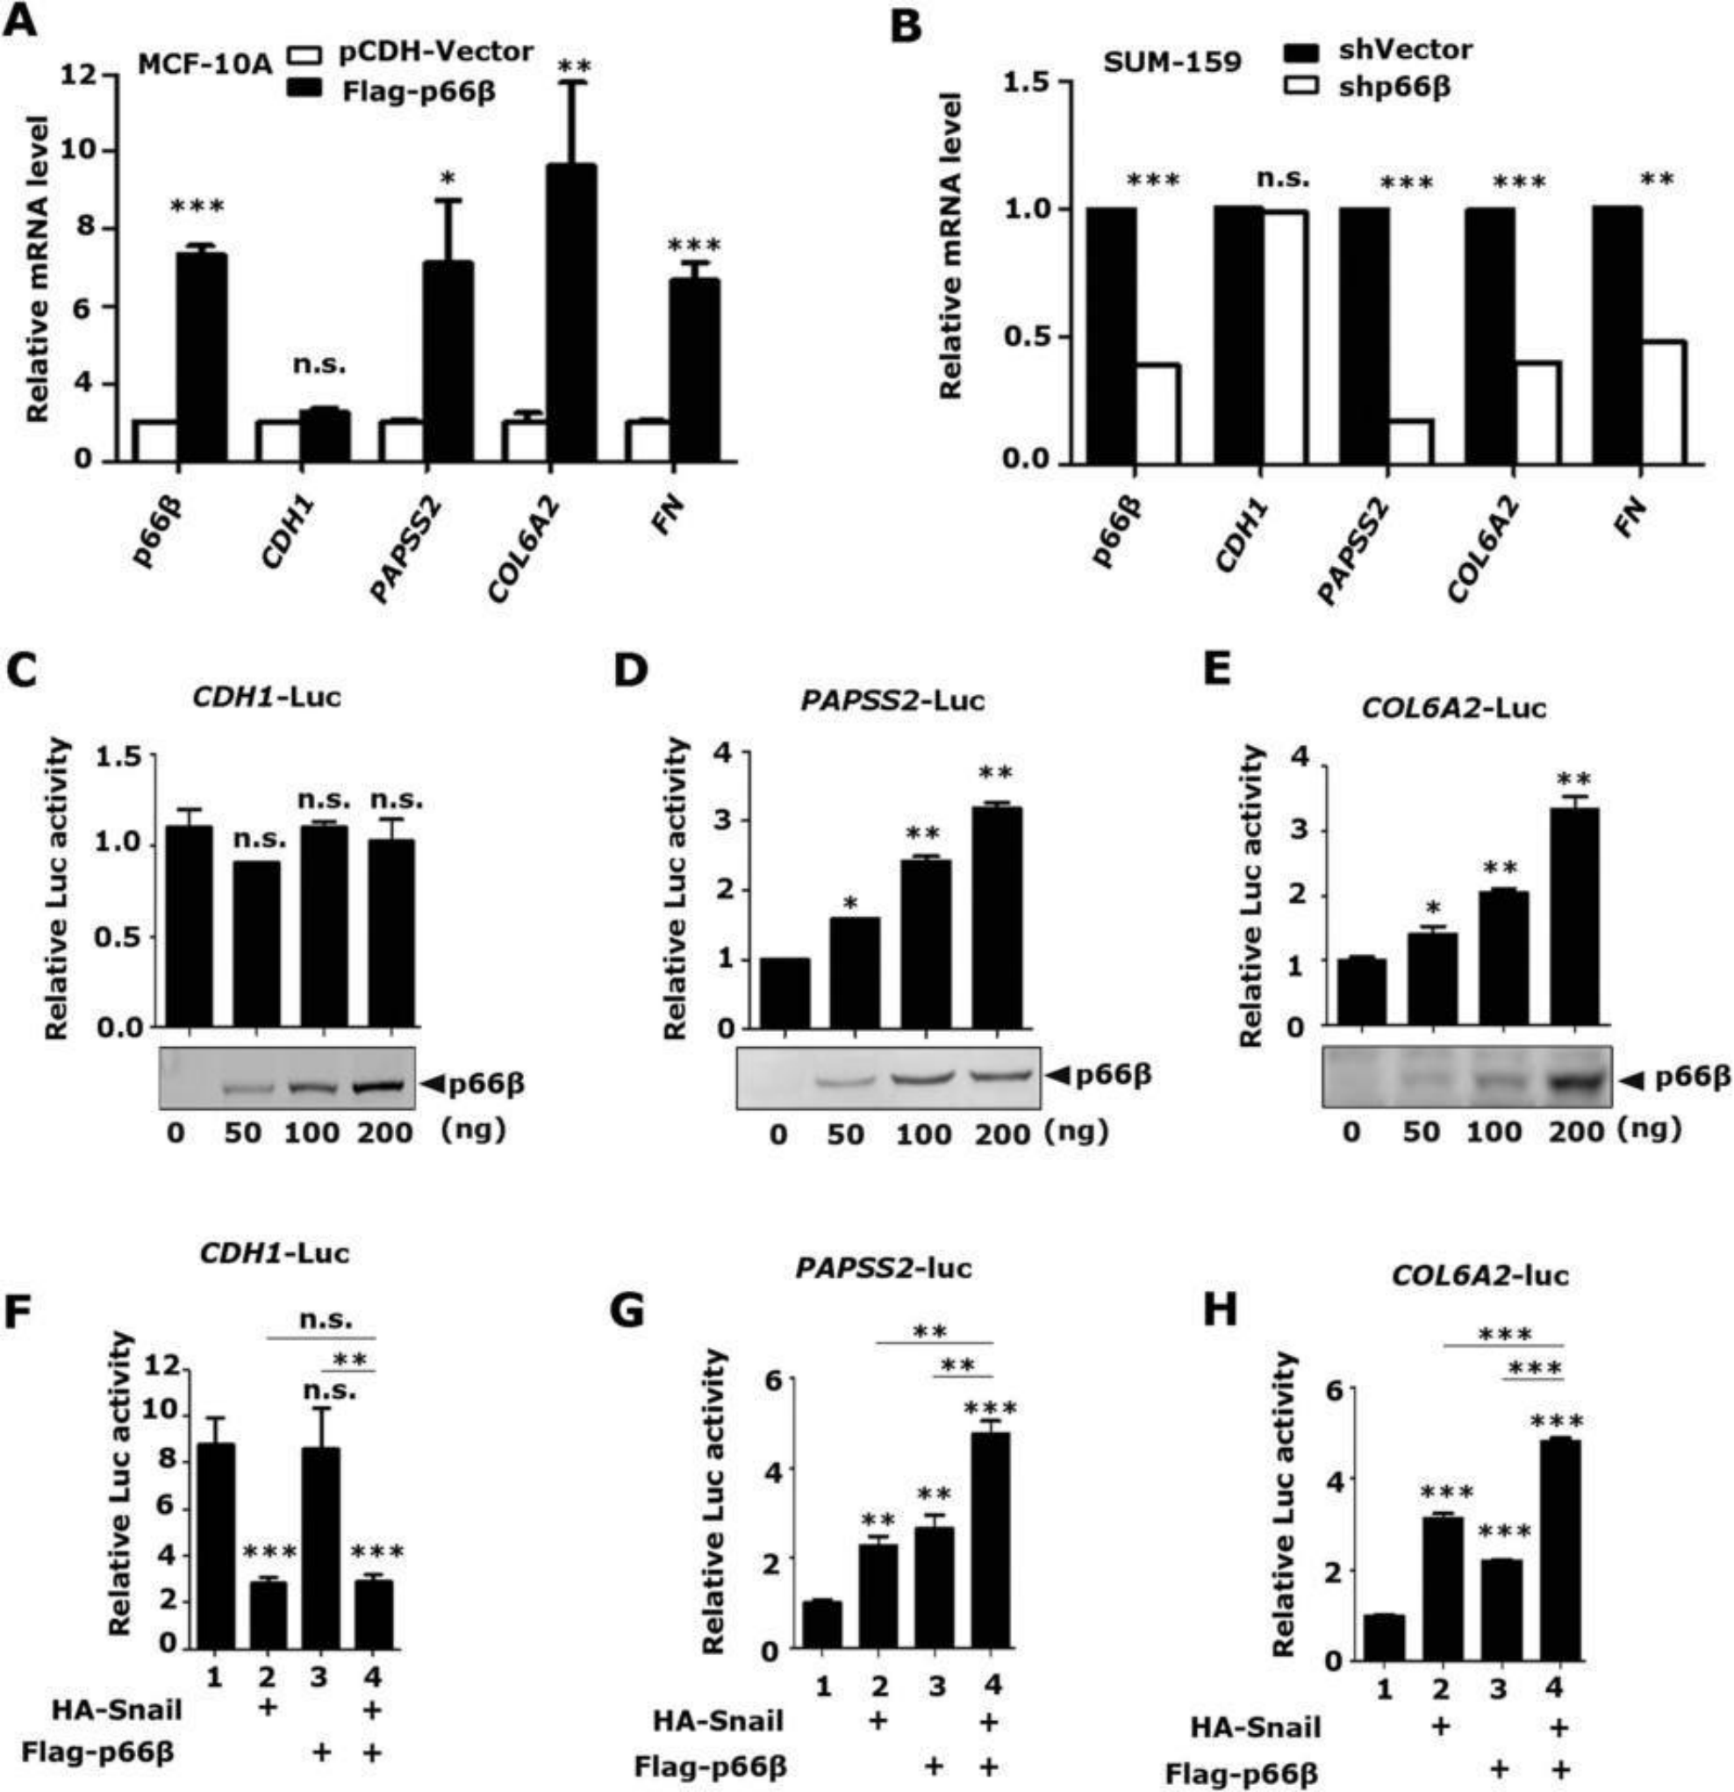
Fig. 4 Snail and p66β cooperatively transactivate genes. A Stably expressed p66β didn’t induce the mRNA level of CDH1 but markedly increased the mRNA level of PAPSS2, COL6A2, and FN. The relative mRNA expression of CDH1, PAPSS2, COL6A2, and FN was detected by qRT-PCR and normalized by the expression of β-actin. *p < 0.05, **p < 0.01, ***p < 0.001 and n.s.: no signiﬁcance. B Depletion of p66β didn’t affect the mRNA level of CDH1 but resulted in decreased mRNA levels of PAPSS2, COL6A2, and FN. **p < 0.01, ***p < 0.001, n.s.: no signiﬁcance. C–E p66β didn’t induce the CDH1-Luc (C) promoter activity, but the PAPSS2-Luc (D), and COL6A2 -Luc (E) promoter activity. The reporters were co- transfected with HA-p66β in HEK-293T cells. Reporter assays were performed and the luciferase activity was normalized to β-galactosidase activity. *p < 0.05, **p < 0.01 and n.s.: no signiﬁcance. F–H p66β and Snail cooperatively induced the PAPSS2 and COL6A2 promoter activity, not the CDH1 promoter activity. **p < 0.01, ***p < 0.001 and n.s.: no signiﬁcance. All data are shown as the mean ± S.D. from three independent experiments by Student’s t-test.

Next, we performed electrophoretic mobility shift assays (EMSA) to verify the direct binding between Snail and G-box elements. An up-shifted band was observed after incubation of GST-Snail protein prepared from bacterial cells with biotin-labeled G-box oligonucleotides of COL6A2 (Fig. 6B, lane 2). The shifted band disappeared with the addition of unlabeled wild-type oligonu- cleotides but not with unlabeled mutant oligonucleotides (Fig. 6B,

lane 3, 4). These data indicated that the Snail protein speciﬁcally binds to G-box elements in vitro.
Snail directly binds G-box elements via its zinc ﬁnger motifs To determine the regions of the Snail protein that can directly bind to the G-box element, full-length GST-Snail, and its truncated mutants were incubated with biotin-labeled G-box

SPRNGER NATURE Cell Death and Disease (2023)14:382

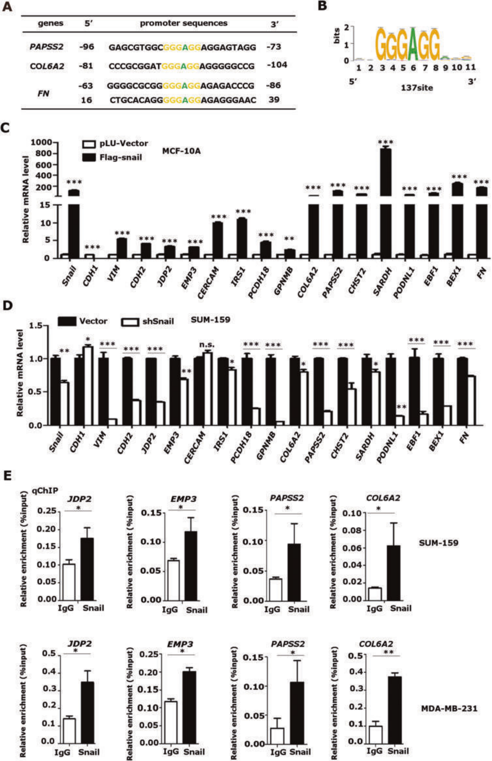

oligonucleotides of COL6A2. The protein/DNA complex was co- precipitated with NeutrAvidin beads and the co-eluted Snail protein was examined by Western blotting. Both full-length Snail and the truncated C-terminal zinc ﬁnger mutant (GST- Snail-CT) readily bound to the COL6A2-G-box element, while the SNAG domain mutant (GST-Snail-NT) did not (Fig. 6C, D).

Moreover, we disrupted the zinc ﬁnger structure by simulta- neous mutations of H176D, C180A, C210D, H230D, H252D, and C259A, and the mutant protein failed to bind to the COL6A2-G- box element (Fig. 6E, F). Collectively, these data demonstrated that Snail directly binds to the G-box element via its zinc ﬁnger motifs.

Cell Death and Disease (2023)14:382 SPRNGER NATURE

Fig. 5 Snail induces transcription of genes containing G-box elements in the proximal promoter regions. A The genes induced by Snail contained the 5’-GGGAGG-3’ (G-box) motif in their promoters. B Prediction of Snail binding sequences by using RSAT software from a published Snail ChIP-seq data in tumor cells prepared from MMTV-PyMT mice and 137 G-box sites, where Snail displayed peak binding activities, were identiﬁed. C The mRNA levels of genes containing G-boxes were increased in Snail stably expressed MCF-10A. The relative mRNA level of genes was detected by qRT-PCR and normalized by the expression of β-actin. **p < 0.01, ***p < 0.001. D The mRNA levels of genes containing G-boxes were reduced in SUM159-shSnail cells. *p < 0.05, **p < 0.01, ***p < 0.001, and n.s.: no signiﬁcance. E Snail bound the proximal promoter regions lanking the G-box motif. The ChIP assays were performed in SUM-159 and MDA-MB-231 cells with a speciﬁc antibody against Snail and the enriched DNA fragments were examined by qRT-PCR and normalized to input. *p < 0.05, **p < 0.01. All data are shown as the mean ± S.D. from three independent experiments by Student’s t-test.

p66β protein enriches on the promoters ﬂanking G-boxes
To determine whether p66β can directly bind to the G-box element, EMSA assays were performed by incubating the biotinylated COL6A2-G-box with cell extracts prepared from HEK- 293T cells expressing wild-type Flag-p66β. Remarkably, adding p66β protein resulted in shifted bands containing the biotinylated oligonucleotide COL6A2-G-box elements, which disappeared upon the addition of unlabeled wild-type oligonucleotides, but not the unlabeled mutants (Fig. 7A). ChIP assays using p66β antibodies indicated that p66β enriched endogenous DNA fragments from the promoters of JDP2, EMP3, PAPSS2, and COL6A2 lanking G-box sites (Fig. 7B). Taken together, these data demonstrated that p66β enriches on the promoter lanking G-boxes.
p66β protein is indispensable for Snail to bind the G-box elements
To examine the role of p66β in Snail-mediated transactivation, we performed DNA pull-down assays to examine the binding of Snail to the G-box elements in the presence of p66β. Surprisingly, p66β alone bound the G-box probes with a relatively high afﬁnity and enhanced Snail binding to the G-box probes (Fig. 8A).
To further examine the binding activity of Snail and p66β at the endogenous target chromatins, we performed ChIP assays in SUM- 159 cells bearing speciﬁc shRNAs to deplete p66β or Snail expression (Fig. 8B). Consistently, both Snail and p66β were associated with the promoter chromatin lanking the G-box elements of JDP2, EMP3, PAPSS2, and COL6A2 in SUM-159-shVector cells, whereas depletion of p66β or Snail, respectively, resulted in decreased binding of Snail and p66β to these promoters (Fig. 8C–F). Collectively, these data demonstrated that p66β is required for Snail to efﬁciently bind G-box elements.

DISCUSSION
In this study, we demonstrated that Snail cooperates with p66β to transactivate target gene transcription by directly binding G-box elements in their promoters and that the induction of gene expression by Snail does not require the SNAG domain (Fig. 8G). Snail interacts with the CR2 domain of p66β via the zinc ﬁngers. Snail by itself weakly binds to the G-box elements, while p66β can markedly enhance Snail binding afﬁnity to G-box elements, and depletion of p66β results in diminished Snail binding to the endogenous promoters, indicating that p66β is critical for Snail- mediated transactivities. More importantly, ectopic expression of p66β promotes breast cancer cell migration and metastasis, whereas depletion of p66β is detrimental to Snail-mediated cell migration and metastasis. Collectively, these data indicated that Snail cooperates with p66β to induce gene expression by directly binding to the G-box elements in the promoters.
Growing evidence has indicated that Snail functions as a transcriptional activator and directly induces gene expression. Earlier studies found that the Snail transcriptional activation recognition motif is still E-box. The E-boxes in the regulatory region of ERCC1 and MMP15 were recognized by Snail [24, 25]. As the research unfolded, it was found that Snail recognition sequences were not limited to the E-box, the new binding

sequences were discovered. A novel Snail-responsive motif, 5I- TCACA-3I, in the promoters of ZEB1, MMP9, and p15INK4b, has been identiﬁed and activated by Snail in collaboration with EGR-1 and SP-1 [28, 29]. In this study, we denote, G-box (5I-GGGAGG-3I), a new element recognized by zinc ﬁngers in the C-terminal of Snail and important for transactivation. Interestingly, a fragment of the Fibronectin1 promoter containing G-box, 5I-GGGGGAGGAGAGG- GAACCCCAGGCGCGAGC-3I, was bound by Snail extraction, not the GST tagged Snail [30]. Whether there are similar consensus binding motifs for Snail to upregulate gene expression is worth investigating in the future.
The role of the SNAG domain in Snail-mediated gene induction is controversial. The SNAG domain of Snail is essential for both the suppression of E-cadherin and the activation of ERCC1 in head and neck squamous cell carcinoma cells [24], while in another report, the transactivation of β-catenin-dependent reporter by Snail does not require the SNAG domain but the zinc ﬁngers [41]. In this study, we showed that deletion of SNAG does not affect the transactivation of target genes.
p66β protein was previously identiﬁed as a key component of the NuRD complex, which modiﬁes chromatin structure to maintain gene repression [32, 35, 36]. Notably, Grzeskowiak et al. reported that p66β induces Myc expression in KRAS- mutant lung cancer cells, indicating that p66β could function as a transcriptional activator [39]. Our data demonstrated that p66β can directly bind G-box elements and induces G-box-containing promoter activity. In contrast, p66β does not bind E-box elements and consequently, does not affect E-box-driven promoter activity. The Snail/p66β complex and Mi-2/NuRD exist mutually exclusively in cells since Snail competes with the MTA2 protein for p66β.
Both Snail and p66β contain zinc ﬁnger motifs. The snail contains four C2H2 types of zinc ﬁngers. The CR2 domain of p66β contains a GATA zinc ﬁnger protein. It is known that zinc ﬁngers are not only responsible for speciﬁc DNA binding but also function as protein-protein interacting modules [42, 43]. In this study, we demonstrated that Snail binds to the CR2 domain of p66β, which contains a GATA zinc ﬁnger, via its C2H2 zinc ﬁngers. We speculate that Snail and p66β may also dimerize through their zinc ﬁnger motifs, resulting in the remodeling of their binding speciﬁcity and afﬁnity toward G-box elements to activate gene expression. These studies have uncovered a novel mechanism for Snail-mediated transcriptional activation. The Snail/p66β complex binds to G-box elements to induce target gene expression. Biologically, p66β is critical for Snail to promote cell migration and metastasis.

MATERIALS AND METHODS Plasmids
The pLU-GFP-Flag-Snail, pCMV5-HA-Snail, and pCDNA3.1-Flag-Snail plas- mids have been described previously [40]. GST-Snail and its truncated plasmids were subcloned into pGEX-4T-1(28-9545-49, GE Healthcare) by PCR between BamH I (R3136M, NEB) and EcoR I (R3101M, NEB) restriction enzyme sites. The GST-Snail-ΔZn was subcloned from GST-Snail using point mutation as indicated in Fig. 6E. The pCDNA-Flag-p66β plasmid was a kind gift from Dr. Renkawitz. Deletion mutants of Flag-p66β and pCDH-Flag- p66β plasmids were subcloned into the pCMV4-Flag-Vector (E7158, Sigma- Aldrich) and pCDH-CMV-MCS-EF1-Puro-Vector (CD510B-1, System

SPRNGER NATURE Cell Death and Disease (2023)14:382

Table 1. The G-box sequence is highly conserved in human and mouse gene promoters.

Genes | Species | 5' | Sequences | 3' | Strands
BEX1 | Human | -167 | CGCACAGACGGGAGGAGGGGGGTG | -144 | (+)
BEX1 | Mouse | -427 | TGTCTCCAAGGGAGGGGGAGGGAG | -404 | (+)
CERCAM | Human | -605 | GACCGCCGCGGGAGGACGCGCCCA | -582 | (+)
CERCAM | Mouse | -688 | CCCGCACTTGGGAGGCAGAGGCAG | -664 | (+)
CHST2 | Human | -449 | TGGAGCGGTGGGAGGACGCGGAGC | -472 | (-)
CHST2 | Mouse | -757 | GCTGCTGGGGGGAGGGGAGGGCGC | -774 | (-)
CHST2 | Human | 297 | TCCATCACCGGGAGGATGCCCGGG | 274 | (-)
CHST2 | Mouse | 33 | GCGGCGCCCGGGAGGATGCTGCTA | 10 | (-)
COL6A2 | Human | -81 | CCCGCGGATGGGAGGAGGGGGCCG | -104 | (-)
COL6A2 | Mouse | 109 | CTGGGGGAGGGGAGGAAAGGAAGG | 86 | (-)
EBF1 | Human | 396 | TTTTCAAGGGGGAGGAGATTTTCC | 419 | (+)
EBF1 | Mouse | 819 | ATTTTCAAAGGGAGGAGATTTTTC | 842 | (+)
EMP3 | Human | -106 | AGCAAGGGAGGGAGGAAGGCGGTG | -83 | (+)
EMP3 | Mouse | 41 | TTAAAGGGTGGGAGGAAGGCGGTG | 64 | (+)
Fn | Human | -63 | GGGGCGCGGGGGAGGAGAGACCCG | -86 | (-)
Fn | Mouse | -59 | TGCGCGCCGGGGAGGAGGGTCCGG | -82 | (-)
Fn | Human | 16 | CTGCACAGGGGGAGGAGAGGGAAC | 39 | (+)
Fn | Mouse | 19 | CTGCACAGGGGGAGAAAAGGAGCC | 42 | (+)
GPNMB | Human | 39 | AGGGCCTCGGGGAGGATCATGTGA | 16 | (-)
GPNMB | Mouse | -3 | GGGGCCAGAGGGAGATCATGTGAT | -26 | (-)
IRS1 | Human | 220 | AGGCGGCTGGGGAGGAGGGGAGGG | 197 | (-)
IRS1 | Mouse | 147 | AGTCCGCAAGGGAGGAGGGGAGGG | 124 | (-)
IRS1 | Human | 467 | TGGGGGGTGGGGAGGAGGCGAAGG | 490 | (+)
IRS1 | Mouse | 382 | TTGAAGGGTGGGAGGAGGCAGAGG | 405 | (+)
JDP2 | Human | -217 | AGCGGCCGCGGGAGGAGGGCGCCC | -194 | (+)
JDP2 | Mouse | -230 | AGCATCGGCGGGAGGAGGGCGCCG | -207 | (+)
JDP2 | Human | -123 | AGGGGACCGGGGAGGAGGGGGTGT | -146 | (-)
JDP2 | Mouse | -139 | GAGGGGACGGGGAGGAGGGGGTGT | -162 | (-)
PAPSS2 | Human | -96 | GAGCGTGGCGGGAGGAGGAGTAGG | -73 | (+)
PAPSS2 | Mouse | -96 | GAGCGCGGCGGGAGGAGGAGTAGG | -73 | (+)
PCDH18 | Human | -222 | GGGGGCTGGGGGAGGAGATGGGAG | -245 | (-)
PCDH18 | Mouse | -94 | GGTGGGAGCGGGAGGGTGGCGGGC | -117 | (-)
PODNL1 | Human | -479 | ATTTGCGGGGGGAGGAGGGGGCGG | -456 | (+)
PODNL1 | Mouse | -533 | CCGCCGAGGGGGAGGGGGTGTGTG | -510 | (+)
PODNL1 | Human | -69 | CCCGCCCTGGGGAGGACGGGCAGG | -92 | (-)
PODNL1 | Mouse | -67 | CCGGAGCGAGGGAGGGCGCGCGTG | -90 | (-)
SARDH | Human | -117 | CTCCCCTCTGGGAGGAGGGGTTGG | -94 | (+)
SARDH | Mouse | -138 | TGGGGTGGTGGGAGGAACATTCCT | -115 | (+)
GGGAGG, G-box cis-element. (+), sense strand. (-), antisense stand.

Cell Death and Disease (2023)14:382 SPRNGER NATURE

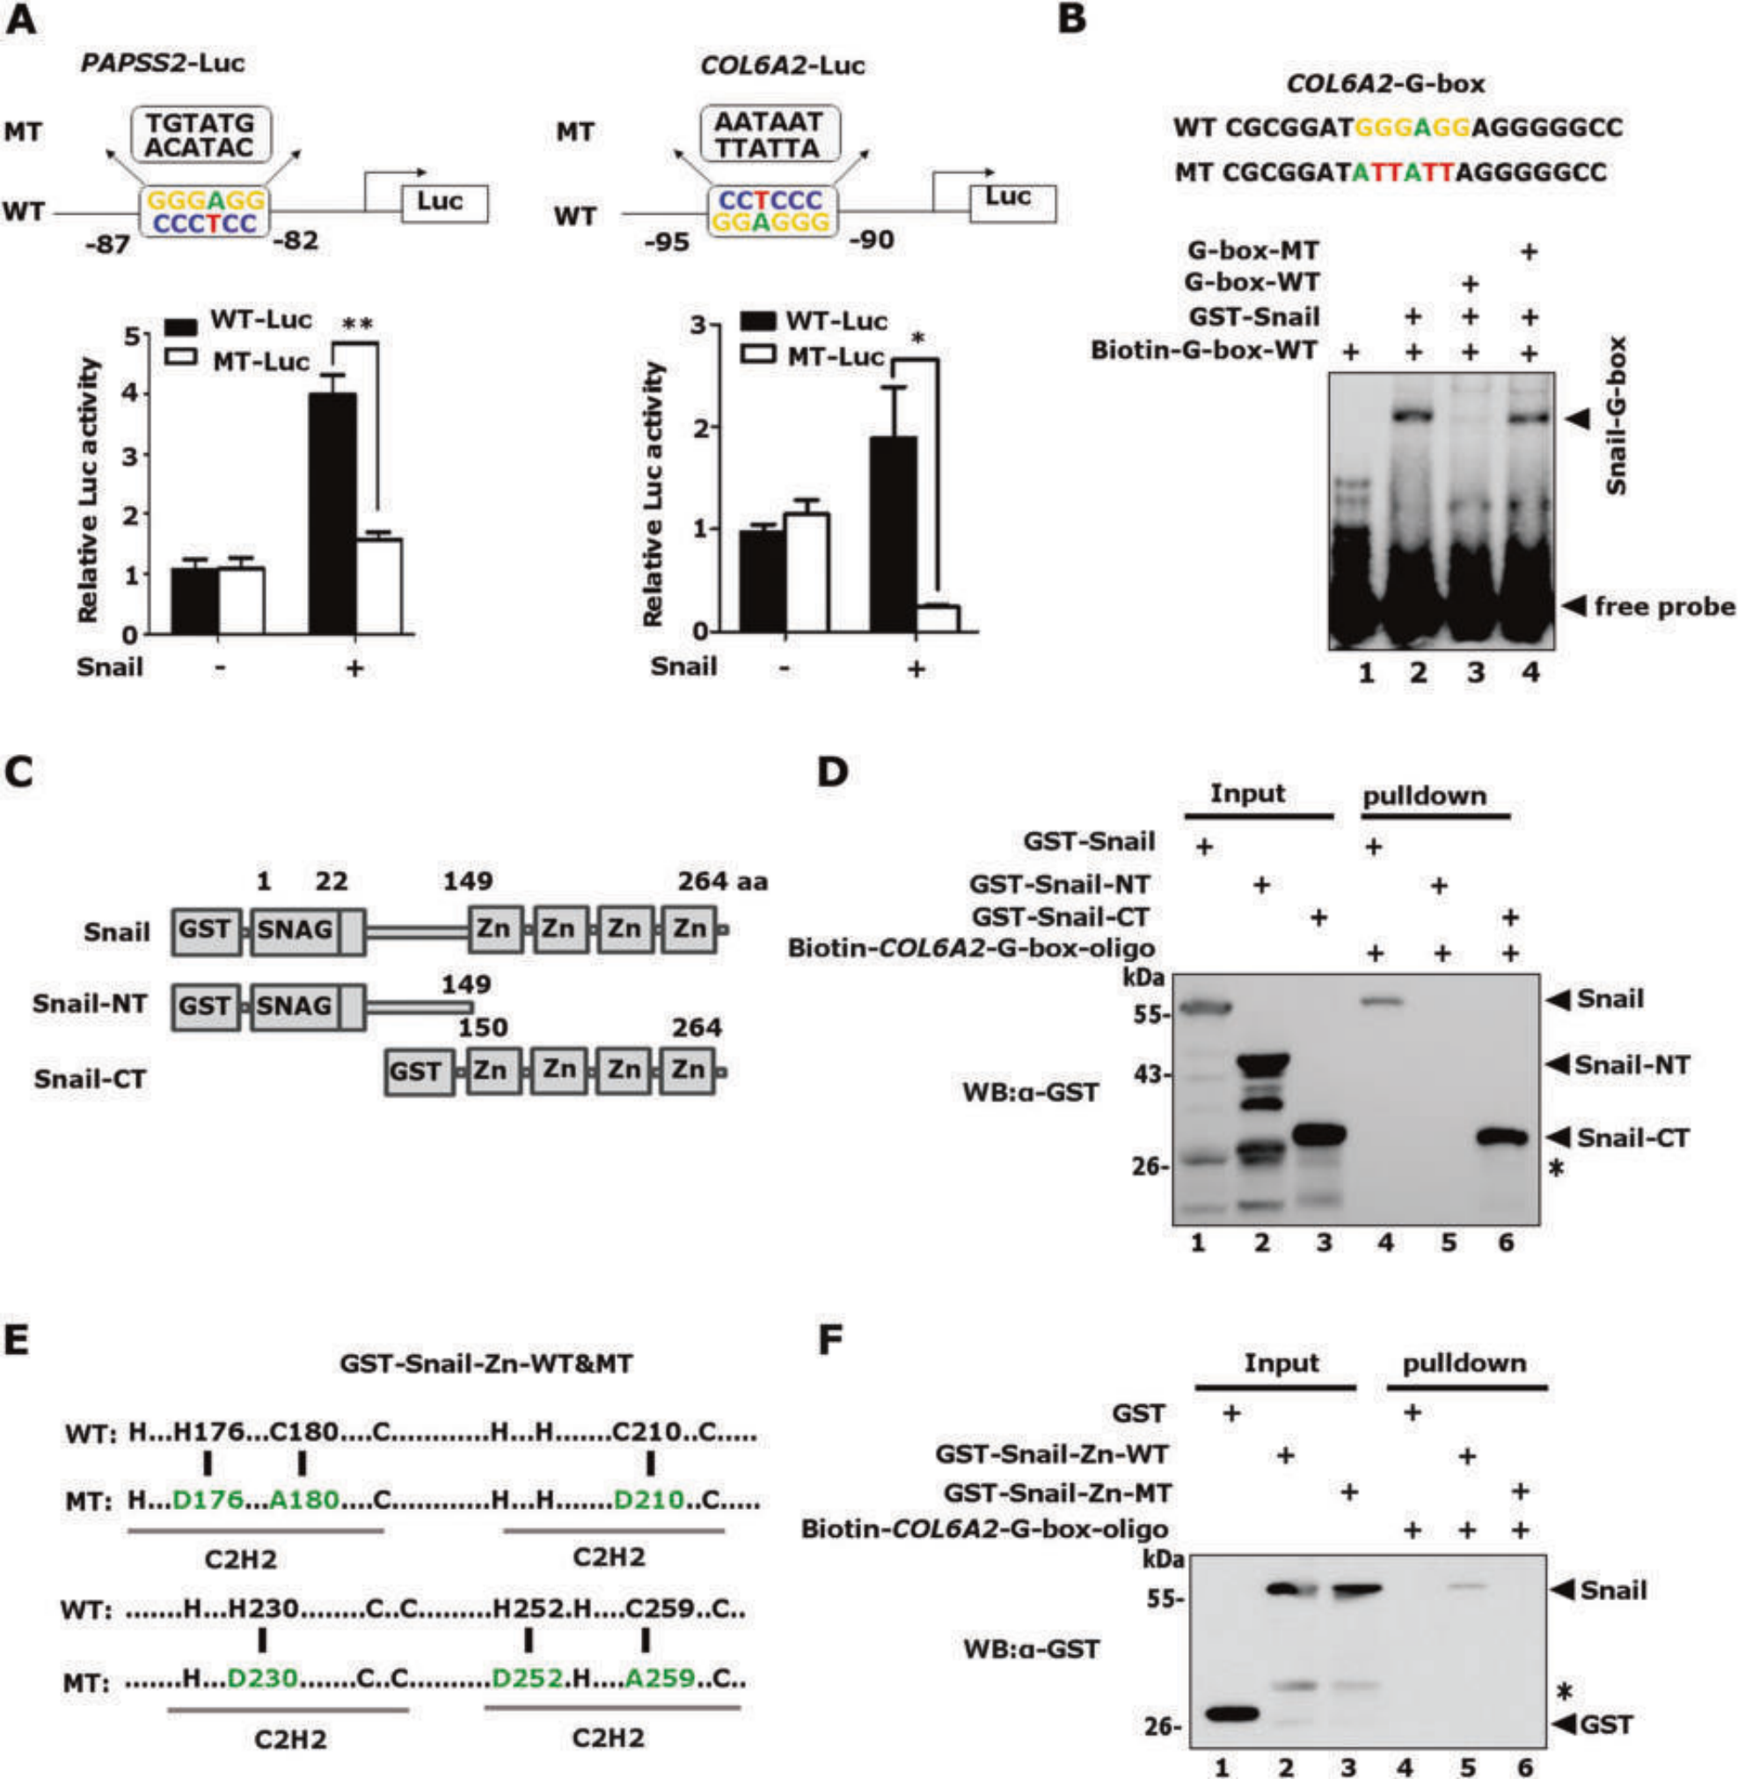
Fig. 6 Snail directly binds the G-box elements through its zinc ﬁngers. A Snail speciﬁcally stimulated the G-box-driven reporter activities. The COL6A2-G-box, PAPSS2-G-box, and their G-box mutation-driven luciferase reporters were transfected with HA-Snail together in HEK-293T cells and the luciferase activity was normalized to β-galactosidase activity. *p < 0.05,**p < 0.01. The data are shown as the mean ± S.D. from three independent experiments by Student’s t-test. B Electrophoretic mobility shift assays (EMSA) were performed by incubating biotinylated COL6A2-G-box probes with bacterially expressed GST-Snail protein. Unlabeled wild-type and mutant probes were included as indicated. C Schematic diagrams showed full-length and truncated Snail proteins. D The biotinylated COL6A2-G-box probes and NeutrAvidin beads were incubated with bacterially expressed full-length GST-Snail, Snail-NT (the SNAG domain), or Snail-CT (the zinc-ﬁnger region), anti-GST was used to detect the COL6A2-G-box probes-bound proteins. *non-speciﬁc band. E Schematic diagrams showed wild type and zinc ﬁnger mutant of Snail proteins. F The zinc ﬁnger mutant failed to bind COL6A2-G-box probes. *non-speciﬁc band.

Biosciences), respectively. The HA-MTA2 plasmid was subcloned into pCMV5-HA-Vector by PCR between BamH I and EcoR I restriction enzyme sites. The pLKO.1-shp66β plasmid was purchased from GE Healthcare, and the short hairpin RNA sequence was 5I-GCTCCATGCTTTCAAACTTT-3I. The oligo of the short hairpin RNA sequence (5I-CCAAGGATCTCCAGGCTCGAA- 3I) was inserted into pLKO.1-tet-on-Vector to construct the shSnail inducible plasmids. The promoter DNA sequences of human PAPSS2 (—96 to +1 bp) and COL6A2 (—119 to +89 bp) were subcloned into a pGL3-Basic-Vector to create the corresponding luciferase reporters.

Cell culture, transfection, and lenti-virus infection
MCF-7, T47D, SK-BR-3, MDA-MB-231, SUM-159, 4T1, and HEK-293T cells were maintained in Dulbecco’s modiﬁed Eagle’s medium (DMEM) supplemented with 10% (v/v) fetal bovine serum and penicillin (50 U/ ml)/streptomycin (50 µg/ml) at 37 °C under 5% CO2 in a humidiﬁed chamber. MCF-10A cells were maintained in DMEM/F12 supplemented with 5% horse serum, EGF (20 ng/ml), insulin (10 µg/ml), hydrocortisone (0.5 µg/ml), cholera toxin (100 ng/ml), penicillin (50 U/ml), and streptomy- cin (50 µg/ml) at 37 °C under 5% CO2 in a humidiﬁed chamber. All cell lines

SPRNGER NATURE Cell Death and Disease (2023)14:382

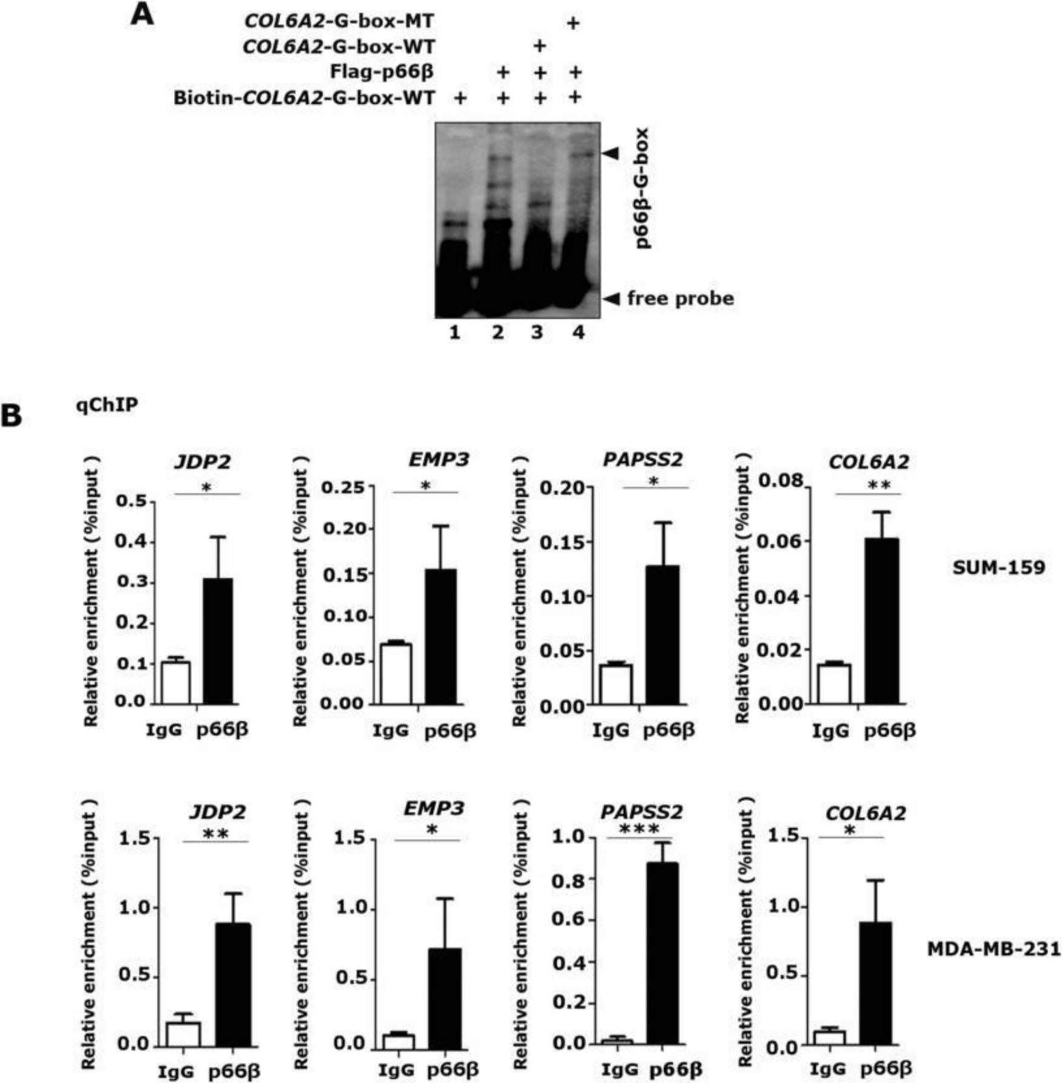
Fig. 7 p66β enriches on the promoters ﬂanking G-boxes. A EMSA assays were performed by incubating biotinylated COL6A2-G-box probes with Flag-p66β protein prepared from HEK-293T-Flag-p66β cells. Unlabeled wild-type and mutant probes were included as indicated. B p66β protein bound the promoter region lanking the G-box motif. The ChIP assays were performed in MDA-MB-231 and SUM-159 cells with a speciﬁcity antibody against p66β and the enriched DNA fragments were examined by qRT-PCR and normalized to input. *p < 0.05, **p < 0.01, and ***p < 0.001. The data are shown as the mean ± S.D. from three independent experiments by Student’s t-test.

were obtained from American Type Culture Collection (ATCC) (https:// www.atcc.org/) and tested negative for mycoplasma contamination.
Transient transfections were carried out using PEI reagent (23966-2, Polysciences) according to the manufacturer’s instructions. For lentiviral infection, viruses were packaged into HEK-293T cells, and injected into MCF-10A, MDA-MB-231, SUM-159, and 4T1 cells.
Afﬁnity puriﬁcation of Snail-interacting protein complex
To purify Snail-associated proteins, pcDNA3.1-Flag-Snail plasmids were stably expressed in HEK-293T cells. A total of 5 × 109 cells were lysed in buffer A (20 mM Tris-HCl (pH 8.0), 150 mM NaCl, 2.5 mM EDTA, 0.5%NP-40, 0.2 mM PMSF, and 0.5 mM dithiothreitol (DTT)). Cell lysates were precleared with the protein A/G agarose (sc-2003, Santa Cruz) for 2 h and then incubated with the anti-Flag M2 afﬁnity gels (F2426, Sigma- Aldrich) at 0.5 ml of beads per 100 mg of cell lysate for 2 h to overnight with rotation. The anti-Flag M2 gels were washed four times with buffer BC500 containing 20 mM Tris-HCl (pH 7.8), 500 mM KCl, 0.2 mM EDTA, 10% glycerol, 10 mM β-mercaptoethanol, 0.2% NP-40, 0.2 mM PMSF, and protease inhibitor cocktail. The protein complexes were eluted with the 3×Flag peptides (F4799, Sigma-Aldrich) at 0.4 mg/ml in buffer BC100

containing 20 mM Tris-HCl (pH 7.8), 50 mM KCl, 0.2 mM EDTA, 10% glycerol, 10 mM β-mercaptoethanol, 0.2 mM PMSF, and protease inhibitor cocktail. The eluted proteins were resolved on 4 to 12% SDS-PAGE gels for Western blotting and colloidal staining analyses. The proteins were excised from the gels and identiﬁed by standard mass spectrometry.
Co-immunoprecipitation (Co-IP), Western blotting (WB), immunoﬂuorescence (IF), and antibodies
For Co-IP assays, HEK-293T cells were transfected as indicated: 36 h later, cells were lysed in IP buffer (1% Triton X-100, 150 mM NaCl, and 50 mM Tris/HCl (pH 7.5), 1 mM PMSF, and protease inhibitor cocktail) and incubated with anti-Flag M2 afﬁnity gels for 4 h at 4 °C. For reverse IP, HEK-293T cells were lysed and incubated with anti-HA antibody and protein A/G agarose for 12 h at 4 °C. Agarose was washed ﬁve times with IP assay buffer, boiled in SDS sample buffer, and subjected to Western blot analysis. Western blotting and immunoluorescence (IF) were performed as previously [40].
The following antibodies were used: mouse anti-Flag (F3165, Sigma- Aldrich), rabbit anti-Flag (F7425, Sigma-Aldrich), rabbit anti-GST (2622, Cell Signaling Technology), mouse anti-β-actin (66009-1-Ig, Proteintech), rabbit

Cell Death and Disease (2023)14:382 SPRNGER NATURE

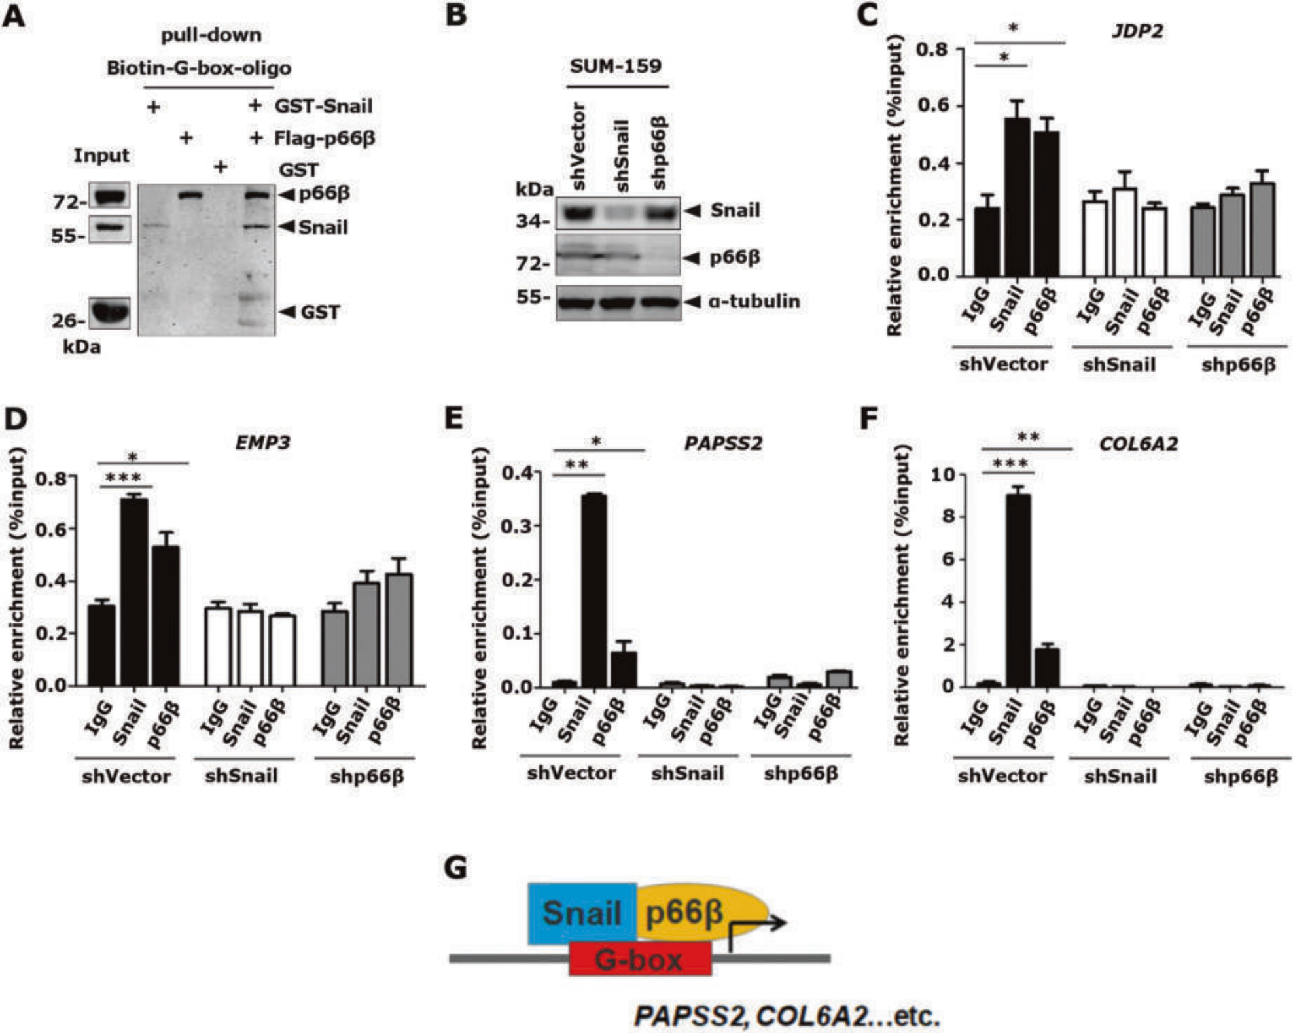
Fig. 8 p66β is indispensable for Snail to bind the G-box elements. A p66β enhanced the Snail binding to G-box. Biotinylated COL6A2-G-box probes and NeutrAvidin beads were incubated with bacterially expressed GST-Snail, and/or Flag-p66β proteins from HEK-293T-p66β cells, Anti-GST, and anti-Flag were used to detect COL6A2-G-box probe-bound proteins. B Western blotting showing the levels of Snail and p66β proteins in SUM-159 cells transfected with speciﬁc shRNAs. C–F Knocking-down of p66β inhibited the binding afﬁnity of Snail to the proximal promoter regions of JDP2, EMP3, PAPSS2, and COL6A2 lanking identiﬁed G-boxes. ChIP assays in SUM-159 cells expressing shVector, shp66β, or shSnail were performed by using speciﬁc antibodies against IgG, Snail, and p66β. The relative enrichment of Snail and p66β on the promoters of JDP2 (C), EMP3 (D), PAPSS2 (E), and COL6A2 (F) was examined by qRT-PCR and normalized to the inputs. *p < 0.05, **p < 0.01, and ***p < 0.001. The data are shown as the mean ± S.D. from three independent experiments by Student’s t-test. G Model in which Snail transactivates gene expression by recruiting p66β protein.

anti-Snail (3879, Cell Signaling Technology), mouse anti-Snail (sc-271977, Santa Cruz), rabbit anti-p66β (ab76925, Abcam), anti-biotin, HRP-linked (7075, Cell Signaling Technology), and rabbit anti-IgG (2729, Cell Signaling Technology), mouse anti-α-tubulin (66031-1-Ig, Proteintech), rabbit anti- Fibronectin1 (15613-1-AP, Proteintech), rabbit anti-E-cadherin (20874-1-AP, Proteintech), rabbit anti-Vimentin (10366-1-AP, Proteintech).
Luciferase reporter assay, quantitative real-time PCR
(qRT-PCR), and chromatin immunoprecipitation (ChIP) assay Luciferase reporter assays and quantitative real-time PCR (qRT-PCR) were performed as described [40].
ChIP assays were performed using 5 × 106 cells and antibodies against Snail (3879, Cell Signaling Technology) and p66β (ab76925, Abcam). Cells were cross-linked with 1% formaldehyde for 10 min at room temperature, followed by quenching with 125 mM glycine (50046, Sigma-Aldrich). After washing with PBS, cells were scraped and centrifuged. The cell pellets were sonicated in lysis buffer (150 mM NaCl, 50 mM Tris-HCl (pH 7.5), 5 mM EDTA, NP-40 (0.5% vol/vol), Triton X-100 (1.0% vol/vol), 1 mM PMSF, and protease inhibitor cocktail) using a sonicator (Bioruptor Plus, Diagenode) and the fragment length (200–500 bp) was determined by agarose gel electrophoresis. After

incubation with beads and antibodies, the ChIP DNA was eluted with elution buffer (50 mM Tris-HCl, pH 8.0, 10 mM EDTA, 1.0% SDS) and incubated with RNAase (R6513, Sigma-Aldrich) at 37 °C for 1 h and Proteinase K (p2308, Sigma-Aldrich) at 55 °C for 2 h. The ﬁnal ChIP products were puriﬁed using an EZNA Cycle-Pure kit (D6492-02, Omega) and analyzed by qRT-PCR using SYBR Green on a Roche system (LightCycler 480II). The comparative cycle threshold method was used to determine the enrichment relative to the input level. The assays were replicated three times. The primer sets used for the qRT-PCR and ChIP assays are listed in Table 2.
ChIP-Seq analysis, peak calling, and binding site identiﬁcation ChIP-seq raw data were downloaded from the GSE611987 [8]. Reads were mapped to the mouse reference genome mm10 using bowtie (http:// bowtie.cbcb.umd.edu) with the parameters -e 70 -k 2 -m 2 -n 2 -best
-concise [44]. The seed length (-l) was set to the read length for each data set. Aligned reads were processed using MACS 1.4.2 (http://github.com/ taoliu/MACS) with the parameters -w -S -space=50 –keep -dup=auto -p 1e-9 [45]. Snail-binding motifs were identiﬁed using the RSAT oligo- analysis tool based on the enriched peak regions (http:// copan.cifn.unam.mx/Computational_Biology/yeast-tools) [46].

SPRNGER NATURE Cell Death and Disease (2023)14:382

Table 2. Primer list.
Primers for qPCR

Name | Forward sequence | Reverse sequence
β-actin-226-F/417-R | 5I-TCACCAACTGGGACGACAT-3I | 5I-CACAGCCTGGATAGCAACG-3I
Snail-F-58-F/193-R | 5I-GCGAGCTGCAGGACTCTAAT-3I | 5I-GGACAGAGTCCCAGATGAGC-3I
CDH1-1502-F/1592-R | 5I-TGGGCCAGGAAATCACATCCTACA-3I | 5I-TTGGCAGTGTCTCTCCAAATCCGA-3I
CDH2-449-F/-649-R | 5I-ACAGTGGCCACCTACAAAGG-3I | 5I-CCGAGATGGGGTTGATAATG-3I
Fibronectin1-6507-F/6838-R | 5I-GAATGTAGGACAAGAAGCTC-3I | 5I-CATCTCCAACGGCATAATGG-3I
Vimentin-1045-F/1207-R | 5I-GAGAACTTTGCCGTTGAAGC-3I | 5I-GCTTCCTGTAGGTGGCAATC-3I
JDP2-191-F/439-R | 5I-TGGAGGTGAAACTGGGCAAGA-3I | 5I-GGTGTCGGTTCAGCATCAGG-3I
EMP3-22-F/171-R | 5I-GTCTCAGCCCTTCACATCCT-3I | 5I-GACATTACTGCAGGCCCATG-3I
CERCAM-635-F/-818-R | 5I-TGGTCCACTCCACCTTCCTT-3I | 5I-GGCACATTCATGTACCCATAACG-3I
IRS1-565-F/729-R | 5I-AGCAAGACCATCAGCTTCGT-3I | 5I-AGAGTCATCCACCTGCATCC-3I
PCDH18-1550-F/729-R | 5I-ATGTAACCATTGACCCAT-3I | 5I-ATTGCCCTTATTCTTGTG-3I
GPNMB-1476-F/1644-R | 5I-GCCTTTAAGGATGGCAAACA-3I | 5I-TGCACGGTTGAGAAAGACAC-3I
PODNl1-169-F/334-R | 5I-GACTGTGATGGCTTGGACCT-3I | 5I-CTTCGGAGGAGATGAGGTTG-3I
PAPSS2-1488-F/1785-R | 5I-CAGTTGCGCAATCCTGTCCACAAT-3I | 5I-AGAAATTGGCACCCGCAATCATCC-3I
CHST2-1322-F/1485-R | 5I-TTTTGTGGGACTGTTGGTGA-3I | 5I-CACCTGTTTGATCTGCTGGA-3I
COL6A2-1872-F/2141-R | 5I-GAGCATTGGGTACACCAACTTCA-3I | 5I-AGGCGGTCGTAGGCAAACTT-3I
BEX1-109-F/323-R | 5I-CCTTTGGATGCTGGTGAAT-3I | 5I-ACTGCCCGCAGACTATGAC-3I
SARDH-678-F/1064-R | 5I-CCGAGGAGCACAGGTCATT-3I | 5I-TCCCAGTCCAGGTCAAAGAG-3I
EBF1-187-F/342-R | 5I-CGGAAATCCAACTTCTTCCA-3I | 5I-AAGCTGAAGCCGGTAGTGAA-3I
p66β-257-F/577-R | 5I-ATGGAGACAACAGGACTGCTGGAA-3I | 5I-TGGGCAGGAGATGGCTGAACAATA-3I
mβ-actin-233-F/471-R | 5I-ACTGGGACGACATGGAGAAG-3I | 5I-GTCTCCGGAGTCCATCACAA-3I
mSnail-84-F/291-R | 5I-TTTACCTTCCAGCAGCCCTA-3I | 5I-CCCACTGTCCTCATCTGACA-3I
mPapss2-1181-F/1427-R | 5I-TTACGCCTCTGGAGCTCAAA-3I | 5I-ACCCTTTCCTCCAGTACAGC-3I
mJdp2-186-F/364-R | 5I-ACCCGTGAAGAGTGAGCTAG-3I | 5I-TCAGCTCCTCTATCTGCGTC-3I
mCol6a2-1853-F/2018-R | 5I-GATGCTGCGACTGTGAGAAG-3I | 5I-GTGCCTGTTTCTGACTTGGG-3I
mChst2-1259-F/1498-R | 5I-ACTTGGTGGTGAGGTACGAG-3I | 5I-AGCAAAACTCCTCCACCTGT-3I
mCercam-866-F/1072-R | 5I-TGGAAGCACTAGTGGATGGG-3I | 5I-TGTTGAGTGTCCTGCCATCT-3I
mIrs1-465-F/706-R | 5I-CAAGGAGGTCTGGCAGGTTA-3I | 5I-CCACTTGCATCCAGAACTCG-3I
mBex1-87-F/306-R | 5I-TACCATCAGAAGGGAGCCAG-3I | 5I-CCTTTCCCTCAGCTTCTCCA-3I
mEbf1-1351-F/1558-R | 5I-GCATCACAAGCCACCAATCA-3I | 5I-GCACAATGGCATAGGGTGAG-3I
mPcdh18-1165-F/1410-R | 5I-TCTGGGCTGAATGGGGAAAT-3I | 5I-ATATCGGCTCCTCTGGAAGC-3I
mPodnl1-328-F/554-R | 5I-GATGAGGCCTTTGAGTCCCT-3I | 5I-TGGAAGGTGTTAGGTGGCAA-3I
mGpnmb-1281-F/1516-R | 5I-AGCCTGTACGATCATCTCCG-3I | 5I-TCAGGACACCATTCACTGCT-3I
mEmp3-101-F/250-R | 5I-AAGAGTCCCTGAACCTGTGG-3I | 5I-AGAGGATGAAGGACAGGCAG-3I
mSardh-1490-F/1658-R | 5I-GCTGTGTGTTTCAAGAGCGA-3I | 5I-GGTGGGAAGTCGAAGGTGTA-3I
Primers for ChIP
Name | Forward sequence | Reverse sequence
PAPSS2-qChIP-F/R | 5I-GTGGCGGGAGGAGGAGTAG | 5I-CTCCCGGGAAGGAGGTATAA-3I
EMP3-qChIP-F/R | 5I-AGCTGGGATTACAGGTGTGC | 5I-ACGGAGTCTCAAGAGGTTGG-3I
JDP2-qChIP-F/R | 5I-CCTCTCGCGTCTCTCTCCTA | 5I-CACACCCACTGACCTTAACC-3I
COL6A2-qChIP-F/R | 5I-CCACCCTCTCCACCTCCT | 5I-TAAGCAGCAGGGAGGGAAC-3I
Oligonucleotides | Forward sequence | Reverse sequence
COL6A2-G-box-WT | 5I-GGCCCCCTCCTCCCATCCGCG-3I | 5I-CGCGGATGGGAGGAGGGGGCC-3I
COL6A2-G-box-MT | 5I-GGCCCCCTAATAATATCCGCG-3I | 5I-GCGGATATTATTAGGGGGCC-3I

Protein puriﬁcation, electrophoretic mobility shift assay (EMSA), and biotin-DNA pull-down assays
GST-Snail and its truncated proteins were expressed in E. coli. BL21 cells (CD601-02, TransGen). The proteins were extracted with GST lysis buffer (25 mM Tris-HCl pH 8.0, 150 mM NaCl, 10% glycerol, 0.1 mg/ml lysosome,1 mM PMSF, and protease inhibitor cocktail) and puriﬁed on Glutathione Sepharose (17-0756-01, GE Healthcare). Flag-p66β plasmids

were transfected into HEK-293T cells for 48 h, cell lysates were incubated with anti-Flag M2 afﬁnity gels for 4 h at 4 °C, 3×Flag-peptide (0.4 mg/ml) were used to exchange for the Flag-p66β protein.
Snail DNA-binding activity in vitro was examined by EMSA using the LightShift chemiluminescent EMSA Kit (20148, Pierce) following the manufacturer’s protocols. Probes for gel shift assays were synthesized, biotinylated, and annealed in 10× Curt Smart Buffer (NEB). Each EMSA

Cell Death and Disease (2023)14:382 SPRNGER NATURE

reaction was performed in a ﬁnal volume of 20 μl. GST fusion proteins (12 μg) were mixed with 600 fmol of probes, 10× binding buffer (100 mM Tris, 500 mM KCl, 10 mM DTT; pH 7.5) (2 μl), 50% glycerol (1 μl), 100 mM MgCl2 (1 μl), 1 mg/ml poly (dI.dC) (1 μl), 1% NP-40 (1 μl)), and the presence or absence of unlabeled probes. Electrophoresis was performed on a 6% non-denaturing polyacrylamide gel in 0.5× TBE buffer at 100 V and 4 °C for 2 h, followed by electrophoretic transfer onto a nylon membrane (77016, Pierce). The membrane was then cross-linked with a CL-1000 ultraviolet crosslinker (UVP) and subjected to detection using the Chemiluminescent detection module provided in the kit, following the manufacturer’s protocol. The sequences of the biotinylated probes are listed in Table 2.
Potential Snail-DNA complex-binding abilities were veriﬁed using biotin- DNA pull-down assays. GST-Snail and /or Flag-p66β prepared from HEK- 293T-p66β cells were incubated with biotinylated oligos of COL6A2-G-box and NeutrAvidin agarose resins (29202, Thermo Scientiﬁc) for 8 h at 4 °C. The beads were washed ﬁve times with IP assay buffer, boiled in SDS sample buffer, and subjected to Western blotting.
Transwell, metastasis assays, and hematoxylin and eosin (HE) staining
Transwell assays were performed to assess the cell migration capability. To evaluate migration, MCF-10A cells were harvested after serum-free starvation for 6 h and then resuspended in the plain DMEM/F12 medium. A total of 5 × 104 cells were applied into the upper 8-μm pore transwell ﬁlters (3495, Corning). Complete DMEM/F12 medium was added to the bottom chamber as attractants. After incubation for 20 h, cells were ﬁxed with 4% paraformaldehyde and stained with coomassie brilliant blue. The non-migrated cells on the top of the chamber were removed gently with cotton swabs, and the migrated cells at the bottom of the ﬁlter were quantiﬁed by counting ﬁve (scale bar, 200 μm) randomly chosen ﬁelds using an inverted phase contrast microscope in each experiment. The Experiments were repeated in triplicates. The procedure of migration assays in SUM-159 and MDA-MB-231 cells was essentially the same as that in MCF-10A cells, but with 3 × 104 cells and complete DMEM media as attractants instead. The migrated cells at the bottom of the ﬁlter were quantiﬁed by counting nine randomly chosen ﬁelds (scale bar, 100 μm) using an inverted phase contrast microscope in each experiment. All animal experiments were performed under relevant guidelines and regulations and were approved by the Institutional Animal Care and Use Committee of Shanghai (IACUC: GBT 35892-2018).
Eight-week-old of female BALB/c nude mice were ordered from SLAC Laboratory Co. Ltd (Shanghai, China) and were assigned to experimental groups using simple randomization. 5 × 105 MDA-MB-231 cells (shVector and shp66β) labeled with luciferase were resuspended in 100 μl PBS buffer and were injected into the tail vein of mice (n = 10 for each group). Metastatic tumors were examined by an experimenter blinded to injection condition and experimental cohort using the Xenogen IVIS Imaging System biweekly after the mice were deeply anesthetized by ether. Mice were also deeply anesthetized by ether before decapitation, followed by lung enucleation. Of these, one mouse injected with shVector cells died because of overdue stimulation, resulting in 19 mice for analysis.
For hematoxylin and eosin (HE) staining, murine lung tissues were excised, washed in PBS, and ﬁxed in formalin for 48 h. After ﬁxation, the samples were dehydrated in a graded ethanol series, followed by xylene. Samples were then embedded in parafﬁn, sectioned onto slides (5 mm thick), and allowed to dry. The slides were deparafﬁnized using a standard procedure (xylene × 2 washes, 100% ethanol × 2 washes, 95% ethanol, 70% ethanol, and 50% ethanol) and stained with hematoxylin and eosin (HE) (HT110132, Sigma-Aldrich).
Statistical analysis
Data were shown as mean ± SD and were analyzed by the independent Student’s t-test from three independent experiments. The postoperative survival of patients with triple-negative (ER-/PR-/HER2-) breast tumors was analyzed by the Kaplan–Meier estimator (https://kmplot.com/analysis/) and tested by the log-rank. Statistical signiﬁcance was set at p < 0.05.

REFERENCES
1. Wang Y, Shi J, Chai K, Ying X, Zhou BP. The role of snail in EMT and tumorigenesis.
Curr Cancer Drug Targets. 2013;13:963–72.

2. Cano A, Perez-Moreno MA, Rodrigo I, Locascio A, Blanco MJ, del Barrio MG, et al. The transcription factor snail controls epithelial-mesenchymal transitions by repressing E-cadherin expression. Nat Cell Biol. 2000;2:76–83.
3. de Herreros AG, Peiro S, Nassour M, Savagner P. Snail family regulation and epithelial mesenchymal transitions in breast cancer progression. J Mammary Gland Biol Neoplasia. 2010;15:135–47.
4. Alberga A, Boulay JL, Kempe E, Dennefeld C, Haenlin M. The snail gene required for mesoderm formation in Drosophila is expressed dynamically in derivatives of all three germ layers. Development 1991;111:983–92.
5. Yang J, Antin P, Berx G, Blanpain C, Brabletz T, Bronner M, et al. Guidelines and deﬁnitions for research on epithelial-mesenchymal transition. Nat Rev Mol Cell Biol. 2020;21:341–52.
6. Akalay I, Janji B, Hasmim M, Noman MZ, Andre F, De Cremoux P, et al. Epithelial- to-mesenchymal transition and autophagy induction in breast carcinoma pro- mote escape from T-cell-mediated lysis. Cancer Res. 2013;73:2418–27.
7. Dong C, Yuan T, Wu Y, Wang Y, Fan TW, Miriyala S, et al. Loss of FBP1 by Snail- mediated repression provides metabolic advantages in basal-like breast cancer. Cancer Cell. 2013;23:316–31.
8. Ye X, Tam WL, Shibue T, Kaygusuz Y, Reinhardt F, Ng Eaton E, et al. Distinct EMT programs control normal mammary stem cells and tumour-initiating cells. Nature 2015;525:256–60.
9. Kudo-Saito C, Shirako H, Takeuchi T, Kawakami Y. Cancer metastasis is acceler- ated through immunosuppression during Snail-induced EMT of cancer cells. Cancer Cell. 2009;15:195–206.
10. Taki M, Abiko K, Baba T, Hamanishi J, Yamaguchi K, Murakami R, et al. Snail promotes ovarian cancer progression by recruiting myeloid-derived suppressor cells via CXCR2 ligand upregulation. Nat Commun. 2018;9:1685.
11. Vincent T, Neve EP, Johnson JR, Kukalev A, Rojo F, Albanell J, et al. A SNAIL1- SMAD3/4 transcriptional repressor complex promotes TGF-beta mediated epithelial-mesenchymal transition. Nat Cell Biol. 2009;11:943–50.
12. Kaufhold S, Bonavida B. Central role of Snail1 in the regulation of EMT and resistance in cancer: a target for therapeutic intervention. J Exp Clin Cancer Res. 2014;33:62.
13. Dong C, Wu Y, Yao J, Wang Y, Yu Y, Rychahou PG, et al. G9a interacts with Snail and is critical for Snail-mediated E-cadherin repression in human breast cancer. J Clin Invest. 2012;122:1469–86.
14. Chiang C, Ayyanathan K. Snail/Gﬁ-1 (SNAG) family zinc ﬁnger proteins in tran- scription regulation, chromatin dynamics, cell signaling, development, and dis- ease. Cytokine Growth Factor Rev. 2013;24:123–31.
15. Nieto MA. The snail superfamily of zinc-ﬁnger transcription factors. Nat Rev Mol Cell Biol. 2002;3:155–66.
16. Peinado H, Ballestar E, Esteller M, Cano A. Snail mediates E-cadherin repression by the recruitment of the Sin3A/histone deacetylase 1 (HDAC1)/HDAC2 complex. Mol Cell Biol. 2004;24:306–19.
17. Lin Y, Wu Y, Li J, Dong C, Ye X, Chi YI, et al. The SNAG domain of Snail1 functions as a molecular hook for recruiting lysine-speciﬁc demethylase 1. EMBO J. 2010;29:1803–16.
18. Dong C, Wu Y, Wang Y, Wang C, Kang T, Rychahou PG, et al. Interaction with Suv39H1 is critical for Snail-mediated E-cadherin repression in breast cancer. Oncogene 2013;32:1351–62.
19. Ayyanathan K, Peng H, Hou Z, Fredericks WJ, Goyal RK, Langer EM, et al. The Ajuba LIM domain protein is a corepressor for SNAG domain mediated repression and participates in nucleocytoplasmic Shuttling. Cancer Res. 2007;67:9097–106.
20. Hou Z, Peng H, Ayyanathan K, Yan KP, Langer EM, Longmore GD, et al. The LIM protein AJUBA recruits protein arginine methyltransferase 5 to mediate SNAIL- dependent transcriptional repression. Mol Cell Biol. 2008;28:3198–207.
21. Hou Z, Peng H, White DE, Wang P, Lieberman PM, Halazonetis T, et al. 14-3-3 binding sites in the snail protein are essential for snail-mediated transcriptional repression and epithelial-mesenchymal differentiation. Cancer Res. 2010;70:4385–93.
22. Chen J, Xu H, Zou X, Wang J, Zhu Y, Chen H, et al. Snail recruits Ring1B to mediate transcriptional repression and cell migration in pancreatic cancer cells. Cancer Res. 2014;74:4353–63.
23. Baulida J, Diaz VM, Herreros AG. Snail1: a transcriptional factor controlled at multiple levels. J Clin Med. 2019;8:757.
24. Hsu DS, Lan HY, Huang CH, Tai SK, Chang SY, Tsai TL, et al. Regulation of excision repair cross-complementation group 1 by Snail contributes to cisplatin resistance in head and neck cancer. Clin Cancer Res. 2010;16:4561–71.
25. Tao G, Levay AK, Gridley T, Lincoln J. Mmp15 is a direct target of Snai1 during endothelial to mesenchymal transformation and endocardial cushion develop- ment. Dev Biol. 2011;359:209–21.
26. Hsu DS, Wang HJ, Tai SK, Chou CH, Hsieh CH, Chiu PH, et al. Acetylation of snail modulates the cytokinome of cancer cells to enhance the recruitment of mac- rophages. Cancer Cell. 2014;26:534–48.

SPRNGER NATURE Cell Death and Disease (2023)14:382

27. Reece-Hoyes JS, Deplancke B, Barrasa MI, Hatzold J, Smit RB, Arda HE, et al. The C.
elegans Snail homolog CES-1 can activate gene expression in vivo and share targets with bHLH transcription factors. Nucleic Acids Res. 2009;37:3689–98.
28. Hu CT, Chang TY, Cheng CC, Liu CS, Wu JR, Li MC, et al. Snail associates with EGR-
1 and SP-1 to upregulate transcriptional activation of p15INK4b. FEBS J.
2010;277:1202–18.
29. Wu WS, You RI, Cheng CC, Lee MC, Lin TY, Hu CT. Snail collaborates with EGR-1 and SP-1 to directly activate transcription of MMP 9 and ZEB1. Sci Rep. 2017;7:17753.
30. Stanisavljevic J, Porta-de-la-Riva M, Batlle R, de Herreros AG, Baulida J. The p65 subunit of NF-kappaB and PARP1 assist Snail1 in activating ﬁbronectin transcription. J Cell Sci. 2011;124:4161–71.
31. Rembold M, Ciglar L, Yanez-Cuna JO, Zinzen RP, Girardot C, Jain A, et al. A conserved role for Snail as a potentiator of active transcription. Genes Dev. 2014;28:167–81.
32. Brackertz M, Boeke J, Zhang R, Renkawitz R. Two highly related p66 proteins comprise a new family of potent transcriptional repressors interacting with MBD2 and MBD3. J Biol Chem. 2002;277:40958–66.
33. Merika M, Orkin SH. DNA-binding speciﬁcity of GATA family transcription factors.
Mol Cell Biol. 1993;13:3999–4010.
34. Fujiwara T. GATA transcription factors: basic principles and related human dis- orders. Tohoku J Exp Med. 2017;242:83–91.
35. Denslow SA, Wade PA. The human Mi-2/NuRD complex and gene regulation.
Oncogene 2007;26:5433–8.
36. Feng Q, Cao R, Xia L, Erdjument-Bromage H, Tempst P, Zhang Y. Identiﬁcation and functional characterization of the p66/p68 components of the MeCP1 complex. Mol Cell Biol. 2002;22:536–46.
37. Chen CC, Montalbano AP, Hussain I, Lee WR, Mendelson CR. The transcriptional repressor GATAD2B mediates progesterone receptor suppression of myometrial contractile gene expression. J Biol Chem. 2017;292:12560–76.
38. Pierson TM, Otero MG, Grand K, Choi A, Graham JM Jr., Young JI, et al. The NuRD complex and macrocephaly associated neurodevelopmental disorders. Am J Med Genet C Semin Med Genet. 2019;181:548–56.
39. Grzeskowiak CL, Kundu ST, Mo X, Ivanov AA, Zagorodna O, Lu H, et al. In vivo screening identiﬁes GATAD2B as a metastasis driver in KRAS-driven lung cancer. Nat Commun. 2018;9:2732.
40. Zhang Y, Zou X, Qian W, Weng X, Zhang L, Zhang L, et al. Enhanced PAPSS2/ VCAN sulfation axis is essential for Snail-mediated breast cancer cell migration and metastasis. Cell Death Differ. 2019;26:565–79.
41. Stemmer V, de Craene B, Berx G, Behrens J. Snail promotes Wnt target gene expression and interacts with beta-catenin. Oncogene 2008;27:5075–80.
42. Mackay JP, Crossley M. Zinc ﬁngers are sticking together. Trends Biochem Sci.
1998;23:1–4.
43. Font J, Mackay JP. Beyond DNA: zinc ﬁnger domains as RNA-binding modules.
Methods Mol Biol. 2010;649:479–91.
44. Langmead B, Trapnell C, Pop M, Salzberg SL. Ultrafast and memory-efﬁcient alignment of short DNA sequences to the human genome. Genome Biol. 2009;10:R25.
45. Zhang Y, Liu T, Meyer CA, Eeckhoute J, Johnson DS, Bernstein BE, et al. Model- based analysis of ChIP-Seq (MACS). Genome Biol. 2008;9:R137.
46. van Helden J, Andre B, Collado-Vides J. Extracting regulatory sites from the upstream region of yeast genes by computational analysis of oligonucleotide frequencies. J Mol Biol. 1998;281:827–42.

ACKNOWLEDGEMENTS
We thank Dr. Wen Liu at Xiamen University for his technical support in bioinformatics. We thank Reiner Renkawitz at the Genetisches Institut Justus-Liebig-Universitaet and Jing Yi at the Shanghai Jiaotong University School of Medicine for providing plasmids.

AUTHOR CONTRIBUTIONS
Conception and design: ZH, HJ, and YW. Acquisition of data: XZ, YZ, QZ, and DZ. Analysis and interpretation of data (e.g., statistical analysis, biostatistics, computa- tional analysis): XZ, LM, GW, CX, XZ, and YC. Writing, review, and/or revision of the manuscript: HJ, ZH, YW, and XZ. Administrative, technical, or material support: XZ, JW, JZ, ML, HZ, and CP. Study supervision: HJ, ZH, and YW. All authors have read and approved the ﬁnal manuscript.

FUNDING
This work was supported by the National Natural Science Foundation of China (81372309, 31970679); the Fundamental Research Funds for the Central Universities; the Shanghai Rising-Star Program (19QA1405000); the Shandong Provincial Natural Science Foundation (ZR2021ZD16); the State Key Laboratory of Oncogenes and Related Genes of China; and the Key Laboratory of Cell Differentiation and Apoptosis of the Chinese Ministry of Education.

COMPETING INTERESTS
The authors declare no competing interests.

ETHICS APPROVAL AND CONSENT TO PARTICIPATE
All animal experiments were performed under relevant guidelines and regulations and were approved by the Institutional Animal Care and Use Committee of Shanghai (IACUC: GBT 35892-2018).

ADDITIONAL INFORMATION
Supplementary information The online version contains supplementary material available at https://doi.org/10.1038/s41419-023-05887-w.
Correspondence and requests for materials should be addressed to Yingjie Wu, Zhaoyuan Hou or Hao Jia.
Reprints and permission information is available at http://www.nature.com/ reprints
Publisher’s note Springer Nature remains neutral with regard to jurisdictional claims in published maps and institutional afﬁliations.


Open Access This article is licensed under a Creative Commons
Attribution 4.0 International License, which permits use, sharing, adaptation, distribution and reproduction in any medium or format, as long as you give appropriate credit to the original author(s) and the source, provide a link to the Creative Commons license, and indicate if changes were made. The images or other third party material in this article are included in the article’s Creative Commons license, unless indicated otherwise in a credit line to the material. If material is not included in the article’s Creative Commons license and your intended use is not permitted by statutory regulation or exceeds the permitted use, you will need to obtain permission directly from the copyright holder. To view a copy of this license, visit http:// creativecommons.org/licenses/by/4.0/.

© The Author(s) 2023

Cell Death and Disease (2023)14:382 SPRNGER NATURE

