Zhao et al. Stem Cell Research & Therapy (2025) 16:281 https://doi.org/10.1186/s13287-025-04373-8

Stem Cell Research & Therapy



RESEARCH Open Access

Sea buckthorn-derived extracellular

vesicles foster bone regeneration

through aau-miR168-mediated pathways
Mai Zhao1,2†, Xiaolin Chen2†, Wenyan Wang2, Mengying Li2, Hui Zhang2, Xiuqun Zou2, Jiamin Wang2, Qian Cong4, Xingyuan Ma5, Zhaoyuan Hou2,3*, Haodong Lin1* and Hao Jia2,3*

Abstract

Background Plant-derived extracellular vesicles (P-EVs) possess remarkable therapeutic potential, yet the regenera-
tive capabilities of sea buckthorn-derived extracellular vesicles (SAEVs) remain underexplored. This study aims to eluci- date the osteogenic and bone-healing properties of SAEVs.

Methods SAEVs were isolated from sea buckthorn juice via differential centrifugation and characterized using
electron microscopy and dynamic light scattering. Bone marrow mesenchymal stromal cells (BMSCs) were treated with SAEVs, and cellular uptake was evaluated through fluorescence microscopy and flow cytometry. In vivo, DiD- labeled SAEVs were orally administered to mice to determine biodistribution using IVIS imaging. A murine femoral defect model was employed to assess the bone regenerative efficacy of SAEVs delivered with or without GelMA
hydrogels, analyzed by micro-CT and histological staining. Small RNA sequencing identified SAEV-derived miRNAs, and luciferase reporter assays validated the miRNA-mediated regulation of osteogenic genes.

Results SAEVs efficiently internalized into BMSCs via macropinocytosis, promoting the expression of key osteogenic
markers such as Runx2 and osteocalcin. In vivo, SAEV-GelMA hydrogels significantly accelerated bone regeneration in a femoral defect model without inducing adverse hematological effects, affirming the safety of SAEV administra- tion. Mechanistic investigations revealed an enrichment of miRNAs, particularly aau-miR168, which modulates osteo- genesis through the aau-miR168/LBH/RUNX2 signaling cascade.

Conclusions This study highlights SAEVs as a transformative and biocompatible therapeutic strategy for fracture
healing and osteoporosis management, offering a novel avenue for regenerative medicine.
Keywords Bone marrow mesenchymal stromal cell, Extracellular vesicle, Osteocalcin, Osteogenesis, Runx2, Sea buckthorn

†Mai Zhao and Xiaolin Chen contributed equally to this work.
*Correspondence:
Zhaoyuan Hou
houzy@sjtu.edu.cn
Haodong Lin
haodonglin@hotmail.com
Hao Jia
fonney@sjtu.edu.cn
Full list of author information is available at the end of the article

.BMC

© The Author(s) 2025. Open Access This article is licensed under a Creative Commons Attribution-NonCommercial-NoDerivatives 4.0
International License, which permits any non-commercial use, sharing, distribution and reproduction in any medium or format, as long as you give appropriate credit to the original author(s) and the source, provide a link to the Creative Commons licence, and indicate if
you modified the licensed material. You do not have permission under this licence to share adapted material derived from this article or parts of it. The images or other third party material in this article are included in the article’s Creative Commons licence, unless indicated otherwise in a credit line to the material. If material is not included in the article’s Creative Commons licence and your intended use is not permitted by statutory regulation or exceeds the permitted use, you will need to obtain permission directly from the copyright holder. To view a copy of this licence, visit http://creativecommons.org/licenses/by-nc-nd/4.0/.

Graphical abstract

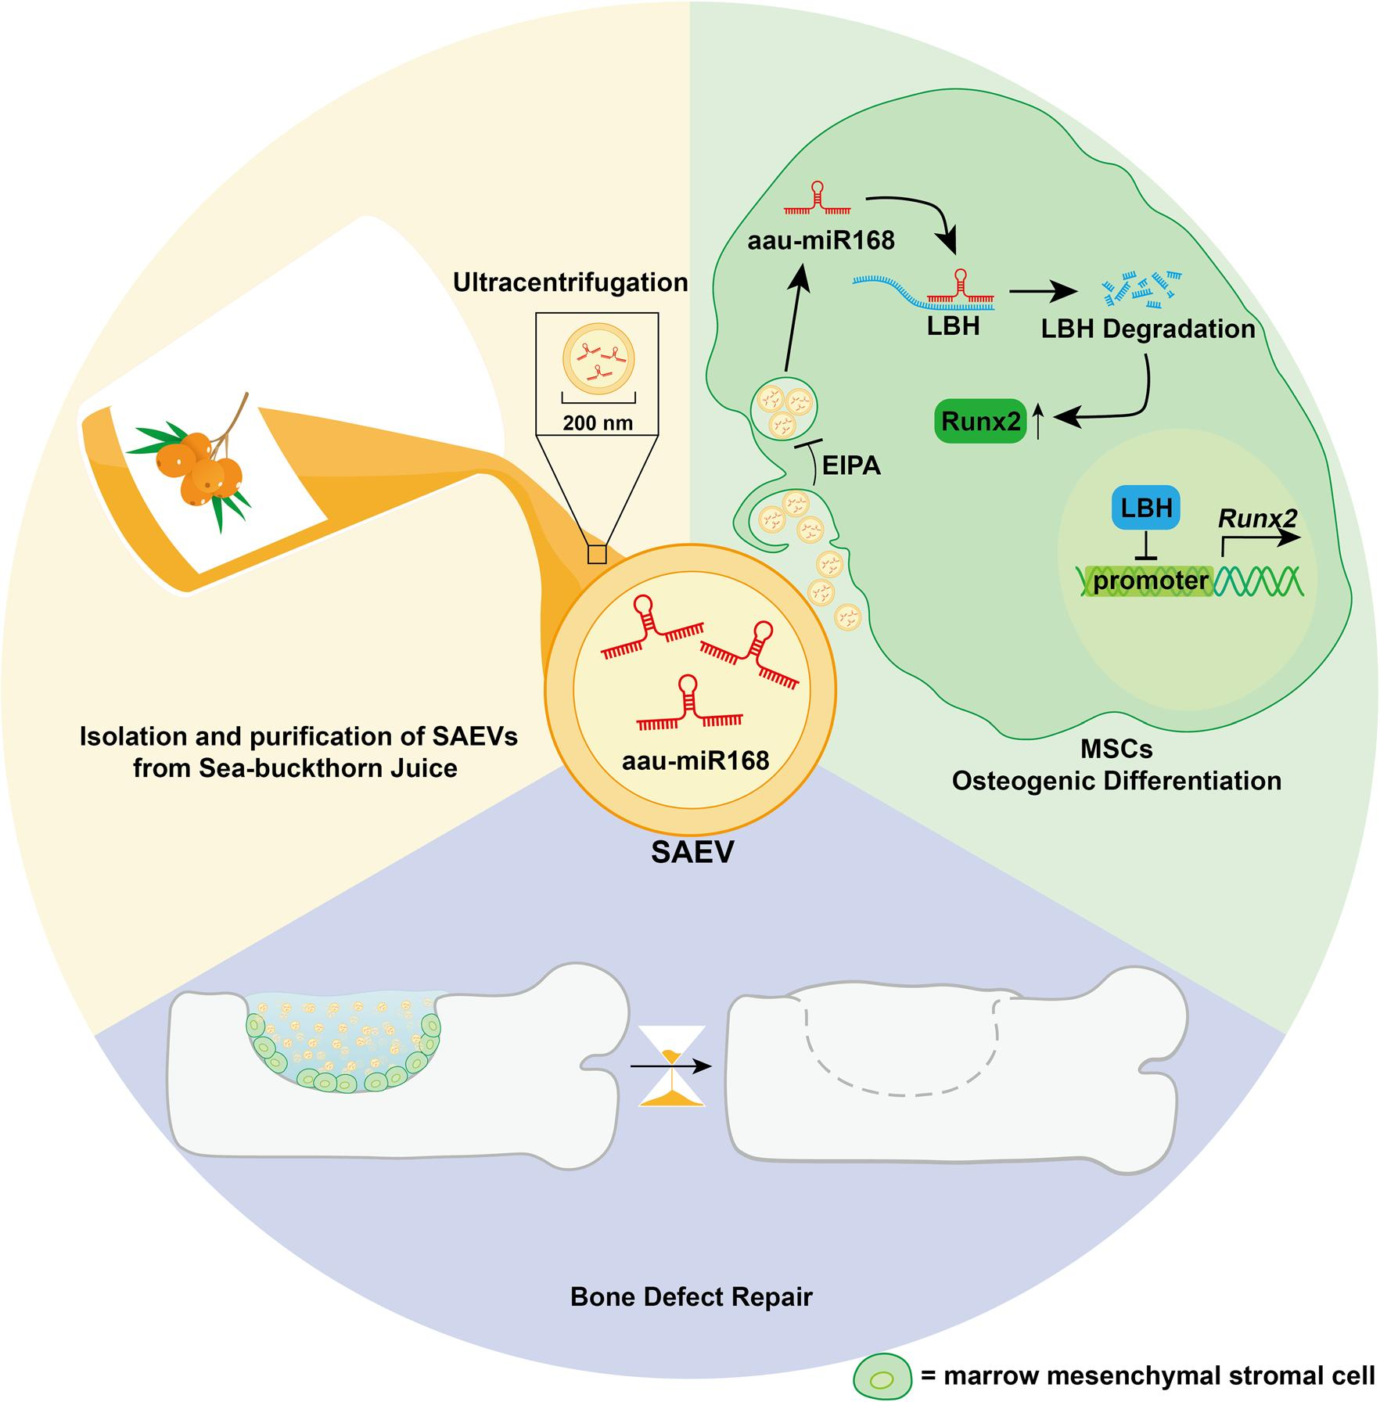

Background
The bone is an organ with intrinsic regenerative capa – bilities involved in several life processes, including injury repair, growth, development, and continuous remodeling, In healthy bones, fractures or defects rarely require extensive intervention to regain their basic properties, In clinical practice, the treatment of large bone defects caused by severe trauma, infection, tumor resection, and degenerative diseases is substantially challenging due to the damage, which often exceeds the

self–healing capacity of the bone tissue, In such cases, bone graft implantation is often necessary to achieve effective outcomes, Autologous or allogeneic bone grafts are commonly used in clinical practice; however, they are associated with potential risks, including lim – ited supply, donor–site morbidity, immune rejection, and possible infection [1, 2], Consequently, the devel – opment of synthetic bone grafts that can effectively fill bone–defect areas, promote bone regeneration, and restore the normal physiological functions of the dam – aged area has become a crucial area of research,

Extracellular vesicles (EVs) derived from plants are typically nanosized vesicles isolated from plants and are characterized by a lipid bilayer membrane with diam – eters ranging from 50 to 1000 nm and exhibit numer– ous biological and morphological characteristics similar to those of animal exosomes, P–EVs are rich in proteins, nucleic acids, lipids, and other small–molecule metabo – lites, enabling them to deliver cargo to plant or animal cells through membrane fusion or endocytosis [3], This allows them to exert anti–inflammatory [4], anti–tumor [5], anti–aging [6], antioxidant [7], and osteogenic–pro – moting effects [8], Compared with exosomes, P–EVs are obtained by squeezing plant fruits, roots, and leaves, offering various advantages, such as low immunogenic– ity, high bioavailability, and low production costs [9], Fur– thermore, engineered P–EVs can serve as nanomedicine delivery platforms, offering potential targeted therapies, Sea buckthorn (Hippophae rhamnoides) is a spiny decid – uous shrub belonging to the Elaeagnaceae family that is widely distributed across Asia and Europe, particularly in northwestern, southwestern, and northern China [10, 11], Sea buckthorn berries are a rich source of bioactive compounds, including flavonoids, polysaccharides, vita – mins, amino acids, and aromatic oils [12], These com – pounds exhibit a range of pharmacological activities, including anti–inflammatory [13], immunomodulatory [14], antioxidant [15–17], anti–tumor [18, 19], antiviral [20, 21], metabolic disorder alleviation [22, 23], neuro – protective [24, 25], and cardiovascular protective effects [26], Flavonoids, triterpenoids, and various organic acids present in sea buckthorn are effective in the treatment of osteoporosis [27–29], Therefore, we postulated that sea buckthorn–derived EVs (SAEVs) may also enhance bone homeostasis and stimulate bone formation, although fur– ther investigation is required to elucidate their mecha – nisms of action,
Given these issues, we extracted exosome–like vesicles from sea buckthorn and demonstrated their capacity to accelerate defect repair in a mouse femoral defect model, In this study, we extended previous research to demon – strate that the osteogenic differentiation promoted by SAEVs relies on the abundant aau–miR168 targeted inhi – bition of LBH, This provides preliminary evidence that LBH suppression of Runx2 occurs via direct action on the Runx2 promoter sequence, The findings of this study offer a promising novel approach to bone defect repair and osteogenesis, providing a cost–effective, biocompat– ible, and bioavailable solution,

Methods

Isolation and purification of SAEVs
SAEVs were extracted from freshly ordered sea buck– thorn juice using differential centrifugation, following

a previously described method [8], Fresh sea buckthorn juice was subjected to sequential centrifugation at 4000 ×g for 30 min and then at 10,000 ×g for 60 min at 4 °C, This process was used to remove cell debris, large vesi – cles, pectin, fibers, and lipids, The resulting pellet was washed with a pre–chilled phosphate–buffered saline (PBS) solution and centrifuged at 100,000 ×g for 70 min to eliminate soluble small molecules, The final pellet was resuspended in PBS and shaken at 4 °C overnight, Sub – sequently, the resuspended vesicles were filtered through a 0,22–μm cell filter, The final SAEV samples were then divided into separate portions, rapidly frozen in liquid nitrogen, and stored in a freezer set to -80 °C,
To prepare DiD–labeled SAEVs, 5 μM DiD perchlorate (MedChem Express, Monmouth Junction, NJ, USA) was used to treat SAEVs under light protection for 25 min, Subsequently, the solution was centrifuged at 100,000 ×g for 70 min to remove the supernatant, followed by wash – ing with PBS in accordance with the established protocol for SAEV preparation, The prepared DiD–labeled SAEV samples were stored at 4 °C for a maximum of 24 h before use,
SAEVs were visualized using transmission electron microscopy (Talos L120 C, Thermo Fisher Scientific) and characterized for size using a Zetasizer Pro (Malvern Panalytical) for dynamic light scattering (DLS),

Cell culture and treatment
To isolate mouse bone marrow mesenchymal stro – mal cells (BMSCs), 4– to 6–week–old female mice were pretreated in a 75% ethanol solution following cervi – cal dislocation for 3 min, The bilateral femurs, tibias, and humerus were dissected in a sterile environment, The marrow cavity was repeatedly flushed with PBS, Collected bone marrow cells were cultured in α–MEM supplemented with 10% fetal bovine serum and 1% peni – cillin/streptomycin, Following a 48–h incubation period, the cell culture supernatant was removed and replaced with a fresh complete medium, Once the cells reached 85–90% confluence, 0,25% trypsin (GIBCO BRL, Grand Island, NY, USA) containing 10 mM EDTA was used to digest the cells, BMSCs were induced to differentiate osteogenically by culturing in osteogenic medium (com – plete medium with 10 mM β–glycerophosphate and 50 μg/mL ascorbic acid) for either 4 or 7 days,

In vitro uptake experiment of SAEVs
SAEVs were labeled with 5 μM DiD for 25 min in the dark, An equal number of BMSCs were seeded onto cell coverslips and cultured for 12 h, Subsequently, the cells were treated with α–MEM complete medium containing DiD–SAEVs at concentrations of 0, 5, 10, or 50 μg/mL for 6, 12, or 24 h, Following the incubation period, the

medium was removed, and the cells were washed with PBS to remove any unbound vesicles, Subsequently, the cells were fixed with 4% paraformaldehyde, washed again, and stained with DAPI (1:1,000), After an additional wash, the cells were imaged,
In experiments involving EIPA treatment, cells were pre–incubated with α–MEM containing 50 or 100 μM EIPA for 30 min before administration of DiD–SAEV, Subsequently, the medium was replaced, and the cells were washed with PBS, All images were obtained using a fluorescence microscope to assess cellular uptake,

Flow cytometric analysis
Flow cytometry was performed to ascertain the extent of SAEV uptake, The fluorescence intensity of the treated cells was quantified using a flow cytometer, with the APC–A channel used to detect the DiD fluores – cence signal, enabling an accurate assessment of SAEV internalization,

In vivo distribution experiment of SAEVs
The work has been reported in line with the ARRIVE guidelines 2,0, Two–month–old male C57BL/6 mice were procured from the SLAC Laboratory Co,, Ltd, (Shang – hai, China) and randomly assigned to the experimen – tal groups, Mice were orally administered DiD–SAEVs at a dose of 10 mg/kg or an equal volume of PBS, Sub – sequently, the mice were imaged using a small animal in vivo imaging system (IVIS) after 24 h, Subsequently, the mice were euthanized, and the hind limb bones, liver, lungs, and digestive tract were collected for imaging,
The mice were anesthetized with isoflurane gas, and the fur at the surgical site was removed using clippers and depilatory cream,
The skin was disinfected with iodine tincture and the surgical instruments were sterilized using high–tempera – ture steam autoclaving under standard protocols, A 1–cm incision was made along the longitudinal axis of the right femur at the designated skin site using a scalpel to expose the underlying muscle, The muscle was bluntly dissected using curved forceps to reveal the femur, A hole, approxi – mately 18–mm deep, was created in the midshaft of the femur using a 0,8–mm drill bit, using PBS to cool the defect site,
In the Sham surgery group, muscles and skin were sutured in layers, In the Vehicle group, 20 µL of 10% GelMA (in PBS) was injected into and around the defect site and cured with a 395–nm UV light for 10 s, followed by layered suturing, In the SAEV group, 20 µL of 10% GelMA containing 100 µg/µL of SAEVs was used, In the SAEV&Oral EV group, in addition to the treatment used in the SAEV group, the mice were orally administered 1 mg/kg SAEVs every 3 days,

Following the surgical procedure, the surgical site was re–disinfected with iodine tincture and 5 mg/kg carpro – fen was subcutaneously administered for analgesia, The mice were placed on a 37 °C warming pad until recovery from the anesthetic effects, The mice were euthanized using carbon dioxide at either 14 or 28 days post–surgery, depending on the group to which they had been assigned, The right femur was harvested, and all muscle tissues were meticulously removed, The bone was fixed in 4% paraformaldehyde,
To facilitate the release of SAEV@GelMA, DiD–labeled SAEVs were loaded onto GelMA at a concentration of 500 μg/mL, Imaging and fluorescence analyses were con – ducted at regular intervals using an IVIS,

Mouse health monitoring
The feeding rooms in the SPF class animal house are monitored by sentinel animals, mainly through the con – tact of sentinel mice with dirty bedding as the main monitoring method, A cage of sentinel animals (2 ani – mals) generally contacts the dirty bedding of about 63 cages of mice, and the contact time is 3 months, and the self–inspection is carried out according to the national standard testing items every 3 months, while randomly selecting sentinel mice in the area or random mice to be sent to a third party for testing,

Micro-CT analysis
Femurs exhibiting defects were scanned using a micro – CT system with a voxel size of 7 μm, A total of 200 slices were selected from the central defect area for the analy– sis, Three–dimensional reconstruction was conducted using DATAVIEWER (1,5,6,2) and CTvox software (3,3), and CTAn software (1,18,4,0) was used for the analysis of the relative bone mineral density (BMD), bone volume (BV/TV), trabecular number (Tb, N), trabecular separa – tion (Tb, Sp), and trabecular thickness (Tb, Th),

Hematoxylin and eosin (H&E) and Masson’s trichrome staining
The fixed right femurs were decalcified using 0,5 M EDTA (pH 8,0), sectioned, and stained with H&E and Masson’s trichrome,

Alkaline phosphatase (ALP) and Alizarin red staining
BMSCs were incubated in osteogenic medium (OM) for 7 days, Following the removal of the culture medium, the cells were rinsed with PBS and fixed with 4% paraformal – dehyde for 30 min, Before staining, the cells were rinsed thrice with PBS, ALP staining was performed using a previously described kit, For Alizarin Red S staining, 2% Alizarin Red S (Sigma–Aldrich, St, Louis, MO, USA) was applied for 30 min at 18 ℃, followed by two rinses with

PBS, All the images were obtained using a light micro – scope, The fluorescence intensity was quantified using ImageJ software,

Quantitative reverse transcription-polymerase chain reaction (qRT-PCR) analysis
RNA was extracted from osteogenically induced BMSCs using TRIzol, and cDNA was synthesized via reverse transcription using reverse transcription, Subsequently, qRT–PCR was conducted using the SYBR Green sys – tem provided by Roche (Basel, Switzerland), The primer sequences are listed in Additional file 1,

Western blotting assay
Following removal of the culture medium and washing, the cells were lysed with IP buffer to extract the total pro– tein, The protein concentration was determined using a BCA Protein Assay Kit (Thermo Fisher Scientific), and equal amounts of protein from each sample were sepa – rated using SDS–PAGE and transferred to PVDF mem – branes, Following the blocking step, which involved the use of 5% skim milk in TBS–T (PBS/0,1% Tween–20), membranes were washed with TBS–T, They were then incubated overnight at 4 °C with primary antibodies (Additional file 2), Subsequently, the membranes were incubated with horseradish peroxidase–conjugated sec– ondary antibodies and enhanced chemiluminescence substrate (Thermo Fisher Scientific), The relative protein levels were visualized using a chemiluminescence imag – ing system,

RNA-sequencing analysis and bioinformatics
BMSCs were treated with SAEVs or Vehicle control (PBS) for 4 days in the presence of OM, Total RNA was extracted using TRIzol reagent (Invitrogen, Paisley, UK), according to the manufacturer’s instructions, RNA integrity was evaluated using an Agilent (Santa Clara, CA, United States of America) 2100 Bioanalyzer (Agi – lent Technologies), The complete list of mouse pathways was retrieved from the Kyoto Encyclopedia of Genes and Genomes (KEGG) pathway database (http://www, genome,jp/kegg/), Functional gene enrichment analysis was conducted based on KEGG pathways, Fisher’s exact test was used to ascertain whether a set of differentially expressed genes (DEGs) exhibited selective enrichment within a given pathway, KEGG pathways containing at least two DEGs with P < 0,05 were deemed significant,

Small RNA-sequencing and bioinformatic analysis
Total RNA extracted from SAEVs was used to prepare the miRNA library, Small RNA sequencing was con – ducted using Novogene (Beijing, China), and miRNA

structure and target genes were predicted using Target Finder software,

Cell transfection
The target gene was cloned from the BMSC cDNA and overexpressed using a pCDH vector constructed in the laboratory, BMSCs were transfected with pCDH–flag – LBH, au–miR168 mimics, NC mimics, au–miR168 inhibi – tors, and NC inhibitors (Shanghai GenePharma Co,, Ltd,, China) using the Lipofectamine™ 3000 Transfection Rea – gent (Invitrogen),

Luciferase reporter system
The 2000 bp promoter sequence upstream of Runx2 was cloned and ligated into the pGL3,0 vector using C57/B6 mouse genomic DNA as a template, Transfection was conducted in 24–well plates in accordance with the fol – lowing protocol, using 293 T cells, Following a 24–h incubation period, the cells were lysed using IP lysis buffer to extract the total protein, Luciferase activity was quantified using a NOVOStar microplate reader (BMG Labtech, Cary, NC, USA) with D–luciferin as the sub – strate, β–Galactosidase (β–gal) activity was assessed with a β–gal substrate as an internal control,

Statistical analysis
Data analysis and charting were performed using GraphPad Prism for Windows (version 9,0,0, GraphPad Software, San Diego, CA, USA, www,graphpad,com), Multiple groups (comprising at least three groups) were subjected to a one–way analysis of variance (ANOVA), and the resulting pairwise comparisons were analyzed,

Results

Isolation and identification of SAEVs
The method for extracting exosome–like vesicles from yam [8] cells was used to extract SAEVs from sea buck– thorn pulp via gradient centrifugation, Low–speed cen – trifugation (4000 ×g) was used to remove plant fibers, large vesicles, and mucilage, Medium–speed centrifuga – tion (10,000 ×g) was used to eliminate whole organelles, whereas ultracentrifugation (100,000 ×g) was used to collect and wash nanosized vesicles, Subsequently, the vesicles were filtered through a 0,22–μm membrane to restrict their size, Finally, exosomes were labeled with DiD dye for subsequent studies (Fig, 1a), The extracted samples were subjected to morphological analyses, Neg – ative–staining electron microscopy revealed that SAEVs primarily had a biconcave disk shape, with approximately 200–nm size distribution (Fig, 1b), The results of DLS analysis further corroborated this finding, indicating an average particle size of 190,3 nm with a standard devia – tion of 7,292 nm, thereby demonstrating good particle

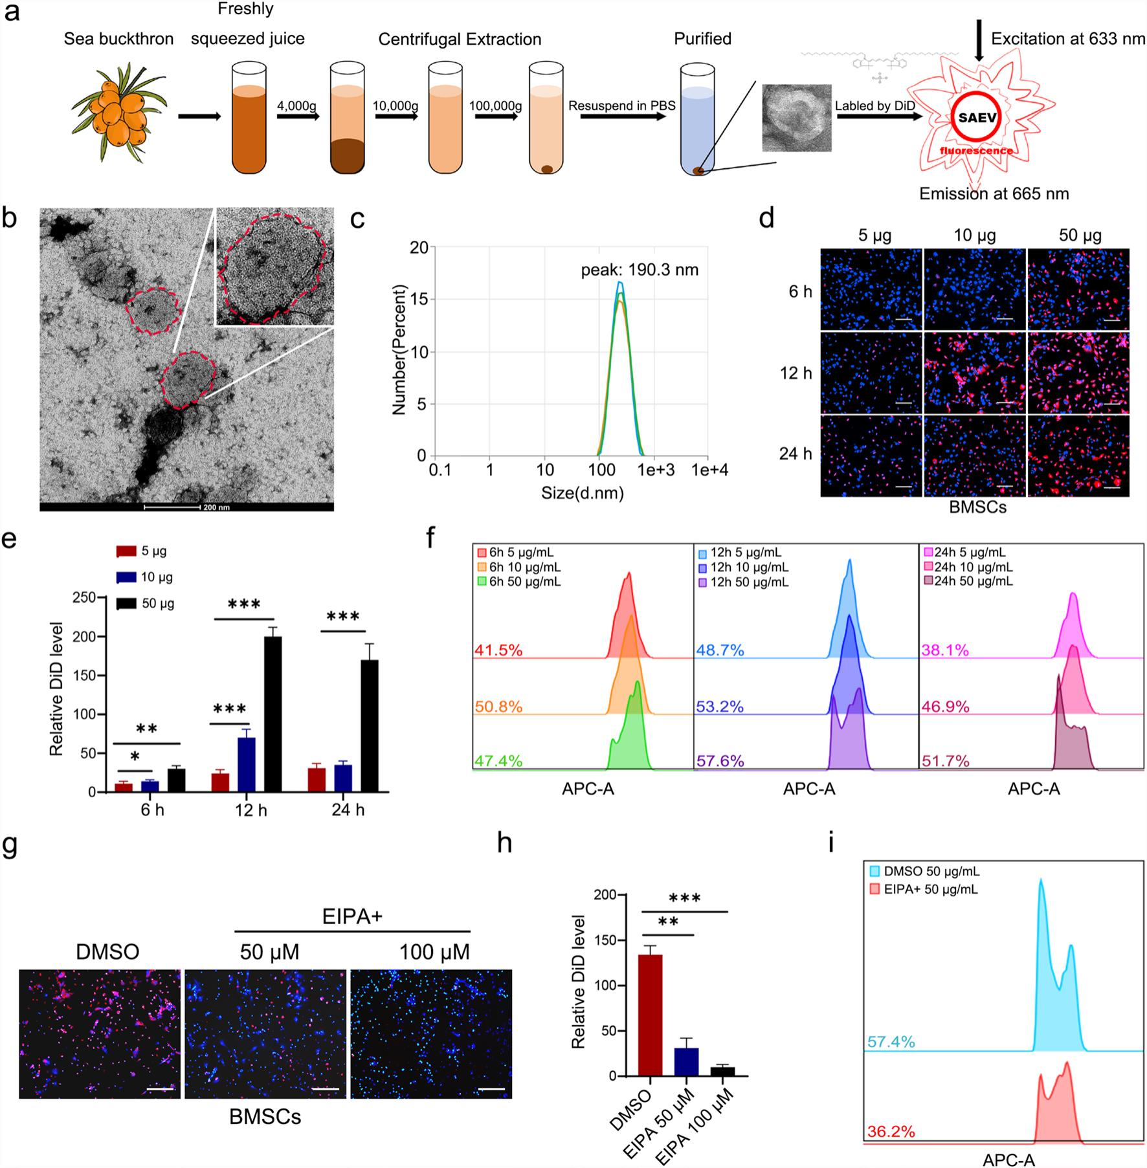
Fig. 1 Isolation, characterization, and uptake of SAEVs. a Flowchart of differential ultracentrifugation procedures for the isolation and DiD labeling of SAEVs. b Negative-staining electron microscopic images of SAEVs (bar = 200 nm). c Dynamic light scattering analysis to determine particle size distribution of the isolated SAEVs. d Uptake of DiD-labeled SAEVs in BMSCs, visualized using a fluorescence microscope (200 ×), with treatments
applied at different concentrations and time points. Blue: DAPI, red: DiD-labeled SAEVs. e Relative levels of DiD-labeled SAEV uptake were analyzed using the ImageJ software. f Flow cytometry was used to analyze the fluorescence levels of cells internalized by the DiD-labeled SAEVs. g EIPA
(50 and 100 μM) was used to inhibit DiD-labeled SAEV uptake in BMSCs for 12 h, and images were captured using a fluorescence microscope
(200 ×). h Relative levels of DiD-labeled SAEV uptake, inhibited by EIPA, were analyzed using the ImageJ software. i Flow cytometric analysis
of the fluorescence levels of cells internalizing DiD-labeled SAEVs with EIPA inhibition. Data represent mean ± SD. n = 3, *P < 0.05; **P < 0.01; ***P < 0.001. BMSC Bone marrow mesenchymal stromal cell, SAEV Sea buckthorn-derived extracellular vesicle

size uniformity (Fig, 1c), These findings indicated that SAEVs are a population of bilayer membrane vesicles with a stable size of approximately 190,3 nm, charac– teristic of exosome–like nanoparticles, To confirm the uptake of plant–derived SAEVs by mammalian cells, we treated BMSCs and 3 T3E1 cells with DiD–labeled SAEVs at various time points and concentrations, The results

demonstrated that SAEVs were internalized by BMSCs at the 6–h mark, reached a peak at the 12–h interval, and persisted in the cytoplasm of BMSCs at the 24–h point, Moreover, the uptake of SAEVs was proportional to their concentration within the range of 0–50 μg/mL (Fig, 1d– f), The uptake of SAEVs exhibited time – and dose – dependent effects comparable to those observed with

exosomes, In addition, the same phenotype was observed in 3 T3E1 cells (Additional file 3), Previous research has demonstrated that macropinocytosis is a crucial path – way for the cellular uptake of exosomes [30], To ascertain whether macropinocytosis represents a mechanism for SAEV uptake by BMSCs, we pretreated cells with EIPA, a macropinocytosis inhibitor, The results demonstrated that with increasing concentrations of EIPA, the uptake of SAEVs was markedly inhibited, although a few SAEVs remained in the cytoplasm of BMSCs, indicating that macropinocytosis may be a primary pathway for SAEV uptake by BMSCs (Fig, 1g-i), SAEVs were successfully isolated and demonstrated the ability to enter mamma – lian cells via phagocytosis,

SAEVs promote bone regeneration in a mouse femoral defect model
Exosomes derived from mammalian stem cells can facili – tate bone regeneration by enhancing the osteogenic differentiation of mesenchymal stromal cells [31], To ascertain whether SAEVs exhibit analogous functional – ity, we constructed a mouse femoral defect model and evaluated the effects of SAEVs via two treatment strate – gies: injecting SAEVs encapsulated in GelMA hydrogel (SAEVs@GelMA) at the defect site and oral adminis – tration of SAEVs in conjunction with GelMA hydro – gel injection (Fig, 2a), Four groups were established: a Sham–operated group, a Vehicle group treated with GelMA, an SAEV group treated with SAEVs@GelMA, and an SAEV&Oral group that received both SAEVs@ GelMA and oral administration of SAEVs, The surgical procedure was conducted on the first day, followed by oral administration of SAEVs or PBS every 3 days, The mice were sacrificed 14 and 28 days post–surgery, and the right femurs were collected for analysis (Fig, 2b), The surgical protocol was conducted according to the scheme outlined in Fig, 2c, The distribution of SAEVs within the GelMA was initially evaluated to assess the feasibility of the experimental design, The results demonstrated that DiD–labeled SAEVs aggregated into small clusters and were uniformly distributed within the hydrogel (Fig, 2d, e), To ascertain whether SAEVs could be released from GelMA, DiD–labeled SAEVs@GelMA were injected into the right legs of mice with femoral defects, and in vivo fluorescence imaging analysis was conducted at regu – lar intervals, The results demonstrated that DiD–labeled SAEVs were released at a gradual rate over time, reach – ing a peak on day 8 and subsequently declining until stabilization by day 16 (Fig, 2f, g), To evaluate the feasi – bility of oral administration, DiD–labeled SAEVs were orally administered, and after 24 h, various organs were extracted for fluorescence intensity measurement, The

results demonstrated that SAEVs can be transported to the stomach, lungs, liver, and femoral epiphysis (Fig, 2h),
As previously outlined, the femurs of the operated mice were harvested at 14 and 28 days post–surgery for micro–CT analysis, Micro–CT three–dimensional recon – struction images of the treated groups after 14 days dem – onstrated the extent of bone regeneration in the sagittal, horizontal, and coronal planes, Notably, the SAEV and SAEV&Oral groups demonstrated more newly formed bone tissue than other groups, as observed morphologi – cally (Fig, 3a, Table 1, and Additional file 4),
Quantitative analysis of the defect sites revealed no sta – tistically significant differences between the Sham and Vehicle groups in the parameters under consideration, In contrast, the SAEV and SAEV&Oral groups exhib – ited notable enhancements in BV/TV, Tb, Th, and Tb, N, and Tb, Sp relative to the control, suggesting that local administration of SAEVs markedly accelerated the repair of bone defects, However, oral supplementation with 1 mg/kg SAEVs did not result in notable enhancement of the therapeutic efficacy of SAEVs@GelMA (Fig, 3b, Table 1), Quantitative analysis of the micro–CT results obtained after a 28–day period revealed no statistically significant differences among the four experimental groups regarding the parameters of BV/TV, Tb, Th, Tb, N, and Tb, Sp, A comparison of the results from the 14– and 28–day groups showed significant improvements in bone density and thickness at day 28, However, no signif– icant differences were observed in the trabecular number or trabecular separation (Fig, 3c, Additional files 5 and 11, and Table 1),
These findings indicate that the slow release of SAEVs from the GelMA hydrogel at the defect site can signifi – cantly promote bone volume growth and restore bone morphology in the short term without causing exces – sive bone proliferation at later time points, H&E and Masson’s trichrome staining was used to evaluate defect repair at 14 and 28 days, respectively, At 14 days, the SAEV and SAEV&Oral groups demonstrated a more substantial bone component within the fibrous callus at the defect site than did the control group, This observa – tion may account for the superior performance of H&E and Masson’s trichrome staining analysis (Fig, 3e, f), At 28 days, H&E staining revealed a denser bone structure at the defect site than that observed on day 14, with the initial callus replaced by cortex–like tissue,
Masson’s trichrome staining also showed more new and mature bone tissue, However, no significant differ– ences were observed among the four groups at the 28–day mark (Additional file 5), Finally, to ensure the safety of SAEVs, we conducted whole blood cytometry on four groups of mice and demonstrated that mice in the SAEVs group did not exhibit any inflamm4atory response,

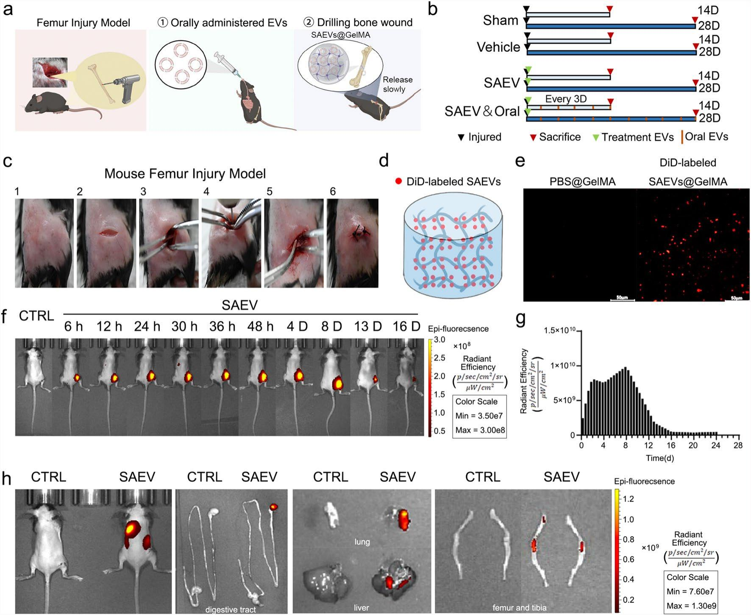
Fig. 2 SAEVs embedded in GelMA promote bone repair at defect sites in a femur drilling defect model. a Schematic illustration of the femoral
drilling defect model in mice, along with the oral administration of SAEVs and hydrogel-based delivery of SAEVs. b Experimental schematic:
8-week-old mice were injured on day 0. The Sham group received injury only; the Vehicle group was implanted with 10% GelMA hydrogel, the SAEV group with hydrogel containing 100 μg/mL SAEVs, and the SAEV&Oral group received the same implant as the SAEV group with additional oral
administration of 1 mg/kg SAEVs. c Mouse Femur Drilling Defect Model construction method. d Schematic diagram of DiD-labeled SAEVs@
GelMA. e PBS@GelMA and DiD-labeled SAEVs@GelMA under fluorescence microscopy (200 ×). Red: DiD-labeled SAEVs. fThe IVIS imaging system illustrates the gradual release of DiD-labeled SAEVs from GelMA. g The density of the DiD dye over time was measured using Living Image software (version 3.0). h After 12 h of SAEVs oral administration, in vivo images of C57/B6 mice and ex vivo images of various tissues, including the stomach, small intestine, large intestine, liver, lung, femur, and tibia, were acquired using an IVIS imaging system. IVIS In vivo imaging system, SAEV Sea
buckthorn-derived extracellular vesicle

suggesting the safety of SAEVs administration (Table 2), These results demonstrate that SAEVs significantly accel – erate the healing of bone defects within 14 days, with no significant difference by 28 days, suggesting that SAEVs do not induce an over–occurrence of osteogenesis, Addi – tionally, oral administration of low doses of SAEV does not promote the healing of bone defects],

SAEVs enhance osteogenic differentiation of mouse BMSCs
To ascertain whether the bone–regenerative effects of SAEVs are contingent upon the osteogenic differ– entiation of BMSCs, we treated BMSCs with varying

concentrations of SAEVs and induced osteogenic dif– ferentiation, The results of ALP and Alizarin Red stain – ing indicated that SAEVs enhanced the ALP activity of BMSCs and promoted the formation of calcified nodules in a dose–dependent manner (Fig, 4a-c), qPCR results revealed that treatment with SAEVs significantly upregu – lated the transcription of Runx2, osteocalcin, and OPG on day 4 (Fig, 4d); Runx2, osteocalcin, and Col1 A1 on day 7 (Fig, 4f), Western blotting also confirmed significant upregulation of Runx2, Col1 A1, OPN, and osteocalcin expression, These findings support the hypothesis that SAEVs play a role in promoting osteogenic differentiation

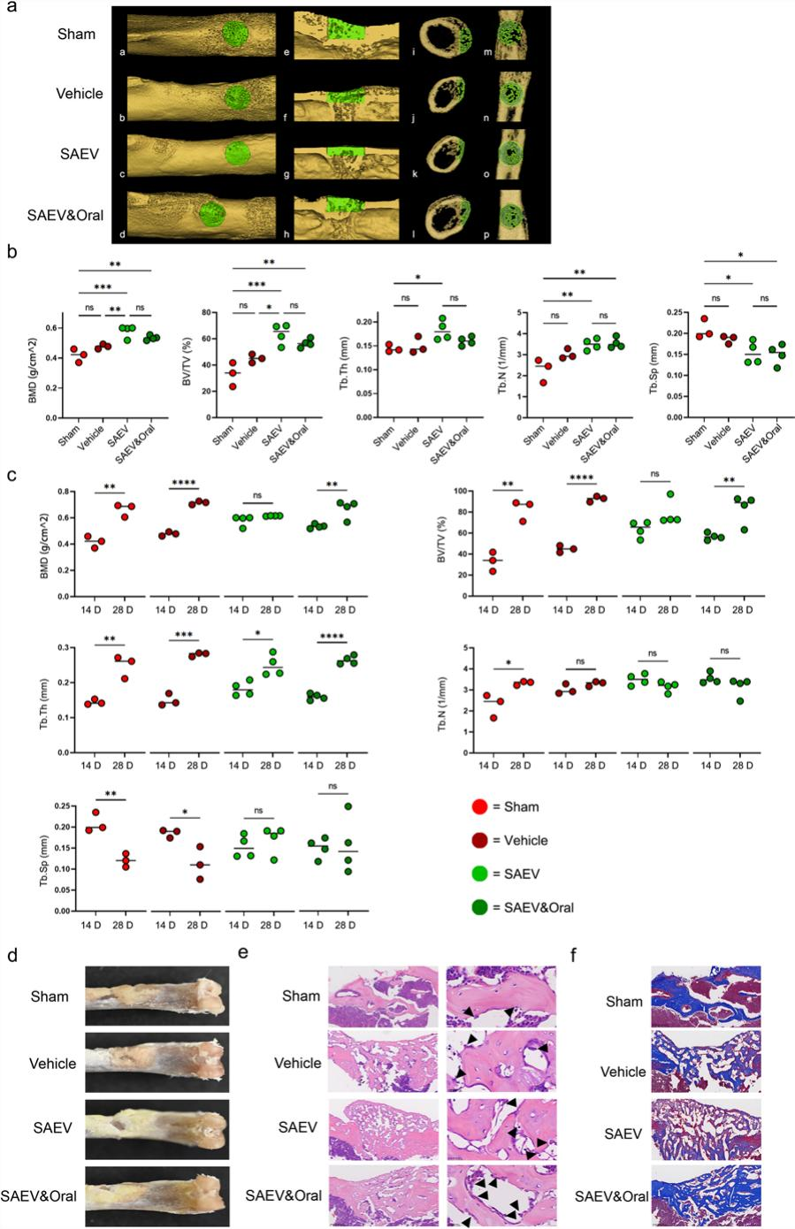
Fig. 3 SAEVs promote bone-defect repair. a Images show samples from day 14, with each column displaying different
views of the bone-defect area. From left to right: macroscopic
view of the bone-defect site and micro-CT three-dimensional
reconstruction images, including sagittal, coronal, horizontal,
and coronal sections, where the green cylindrical region indicates
the defect site of the surgery, with a diameter of 0.7 mm,
penetrating one side of the cortical bone, whereas the red circular
area also represents the defect site. The groups shown from top
to bottom are the Sham group, Vehicle group (PBS@GelMA), SAEV
group (SAEVs@GelMA), and SAEV&Oral group (SAEVs@GelMA
+ oral administration of SAEVs every 3 days). b Quantitative analysis of the defect area, including bone mineral density (BMD), bone
volume per tissue volume (BV/TV), and trabecular thickness (Tb.
Th), where quantification of these parameters was used to assess
the formation of new bone at the defect site. c Comparison of BMD, BV/TV, and Tb. Th within each group on days 14 and 28. d Gross
appearance of all four groups. The staining of osteoblasts at the bone defect area was conducted using both hematoxylin and eosin
(H&E) staining (e) and Masson trichrome staining (f) techniques. The analysis of fractured bones was performed 14 days later
in 2-month-old mice; arrowheads indicate osteoblasts; scale bar: 50 μm. Data represent the mean ± SD. n ≥ 3, *P < 0.05; **P < 0.01; ***P < 0.001

of mesenchymal stromal cells (Fig, 4e, g and Additional files 7, 8), These results illustrate that SAEVs can facilitate osteogenic differentiation of BMSCs via transcriptional and expression–level mechanisms,

Runx2 in BMSCs is significantly upregulated under SAEV treatment
To gain further insight into the mechanisms through which SAEVs regulate osteogenic differentiation, we performed RNA sequencing to analyze the total RNA of BMSCs treated with SAEVs compared with that in the control group, The volcano plot demonstrated that 59 genes exhibited increased expression levels and 54 genes displayed decreased expression levels following SAEV treatment (Fig, 5a), Enrichment analysis demonstrated a significant upregulation of Runx2 in mice (Fig, 5b), cor– roborated by qPCR results (Fig, 5c),

aau-miR168 is abundant in SAEVs
Exosomes typically contain a diverse array of ncRNAs, peptides, and active molecules that regulate the physi – ological and pathological responses of cells, The RNA composition of SAEVs was analyzed using agarose gel electrophoresis (Fig, 5d), which demonstrated that most of the RNA present in SAEVs was small, Subsequently, total RNA was extracted from the SAEVs for small RNA– sequencing (Fig, 5e), The results demonstrated the pres – ence of a considerable quantity of non–coding RNA (rRNA, snoRNA, snRNA, and tRNA) in SAEVs (Fig, 5f), Analysis of miRNAs in SAEVs revealed the presence of 13 highly expressed miRNAs in sea buckthorn, with aau–miR168 being the most highly expressed (Fig, 5g), Moreover, the secondary structures of these 13 miR– NAs were predicted using bioinformatic techniques (Additional file 6), To further ascertain the content and specificity of these miRNAs in SAEVs, we extracted SAEVs and analyzed 13 miRNAs, Compared with the control group (BMSCs exosomes), six miRNAs were sig – nificantly and specifically expressed in the SAEV group, with aau–miR168 exhibiting the highest relative expres – sion (Fig, 5h), The aforementioned study demonstrated that sea buckthorn exosomes are rich in miRNA, which may be a crucial factor responsible for promoting bone healing,

aau-miR168 promotes osteogenic differentiation of BMSCs
To gain further insight into the function of aau–miR168 in osteogenic differentiation, we predicted the second – ary structure of aau–miR168 (Fig, 6a), Moreover, we constructed overexpression and repression groups of aau–miR168 and treated BMSCs in accordance with rel – evant protocols,

Table 1 (a) Micro-CT analysis for Day 14, (b) Micro-CT analysis for Day 28

Groups | BMD (g/cm3) | BV/TV (%) | Tb. Th (mm) | Tb. N (1/mm) | Tb. Sp (mm)
(a)
Sham | 0.417 ± 0.037 | 33.111 ± 7.419 | 0.144 ± 0.006 | 2.286 ± 0.450 | 0.209 ± 0.019
Vehicle | 0.477 ± 0.013 | 45.012 ± 2.648 | 0.150 ± 0.014 | 3.019 ± 0.195 | 0.186 ± 0.008
SAEV | 0.579 ± 0.035 | 63.642 ± 6.716 | 0.183 ± 0.018 | 3.490 ± 0.230 | 0.154 ± 0.023
SAEV&Oral (b) | 0.534 ± 0.014 | 56.650 ± 2.810 | 0.160 ± 0.008 | 3.550 ± 0.216 | 0.150 ± 0.021
Sham | 0.634 ± 0.059 | 76.828 ± 11.934 | 0.246 ± 0.023 | 3.122 ± 0.363 | 0.149 ± 0.051
Vehicle | 0.722 ± 0.018 | 94.470 ± 3.647 | 0.284 ± 0.006 | 3.331 ± 0.101 | 0.096 ± 0.041
SAEV | 0.614 ± 0.001 | 78.757 ± 10.631 | 0.250 ± 0.026 | 3.154 ± 0.211 | 0.171 ± 0.029
SAEV&Oral | 0.667 ± 0.059 | 83.414 ± 11.915 | 0.265 ± 0.010 | 3.145 ± 0.392 | 0.156 ± 0.059

Table 2 Mouse complete blood count experiment: description

Groups | Abbreviation | Unit | Sham | Vehicle | SAEV | SAEV&Oral | Statistical
White blood cell count | WBC | 109/L | 4.52 ± 0.037 | 4.23 ± 0.032 | 4.21 ± 0.012 | 4.34 ± 0.003 | NS
Lymphocyte count | Lymph# | 109/L | 3.9 ± 0.014 | 3.59 ± 0.013 | 3.81 ± 0.023 | 4.12 ± 0.013 | NS
Monocyte count | Mon# | 109/L | 0.11 ± 0.002 | 0.12 ± 0.003 | 0.12 ± 0.012 | 0.10 ± 0.012 | NS
Neutrophil count | Gran# | 109/L | 0.5 ± 0.004 | 0.55 ± 0.005 | 0.53 ± 0.016 | 0.45 ± 0.007 | NS
Percentage of lymphocytes | Lymph% | % | 85.7 ± 0.51 | 90.7 ± 0.51 | 85.7 ± 0.53 | 87 ± 0.54 | NS
Monocyte percentage | Mon% | % | 2.4 ± 0.015 | 2.24 ± 0.01 | 2.12 ± 0.017 | 3.35 ± 0.219 | NS
Neutrophil percentage | Gran% | % | 11.9 ± 0.53 | 12.9 ± 0.44 | 12.1 ± 0.35 | 15.21 ± 0.22 | NS
Number of red blood cells | RBC | 1012/L | 8.1 ± 0.234 | 9.2 ± 0.135 | 8.21 ± 0.132 | 9.23 ± 0.221 | NS
Hemoglobin | HGB | g/L | 121 ± 3.212 | 120 ± 3.113 | 124 ± 3.33 | 151 ± 5.21 | NS
Erythrocyte pressure volume | HCT | % | 35.3 ± 4.103 | 35.2 ± 5.111 | 34.4 ± 4.14 | 35.3 ± 7.12 | NS
Mean red blood cell volume | MCV | fL | 43.6 ± 4.301 | 44.1 ± 5.31 | 52 ± 6.98 | 57 ± 3.12 | NS
Mean red blood cell hemoglobin content | MCH | pg | 14.9 ± 6.202 | 15.2 ± 7.211 | 20.1 ± 8.12 | 20.12 ± 4.205 | NS
Mean erythrocyte hemoglobin concentration | MCHC | g/L | 342 ± 12.403 | 340 ± 14.4 | 312 ± 16.12 | 398 ± 20.23 | NS
Erythrocyte distribution width | RDW | % | 17.3 ± 2.001 | 19.1 ± 2.202 | 17.3 ± 2.23 | 20.23 ± 3.45 | NS
Platelet count | PLT | 109/L | 272 ± 14.12 | 298 ± 13.13 | 272 ± 15.21 | 309 ± 13.35 | NS
Mean platelet volume | MPV | fL | 6.3 ± 3.21 | 7.1 ± 3.21 | 6.23 ± 4.44 | 8.21 ± 4.21 | NS
Platelet distribution width | PDW |  | 16.6 ± 3.11 | 17.2 ± 4.21 | 17.82 ± 4.51 | 19.2 ± 4.44 | NS
Platelet pressure | PCT | % | 0.171 ± 0.012 | 0.181 ± 0.011 | 0.211 ± 0.112 | 0.192 ± 0.215 | NS

The aau–miR168 and repressor group constructs were verified using RT–PCR (Fig, 6b), Further studies on aau – miR168 overexpression demonstrated that the expres – sion of Runx2, OPG, and osteocalcin was significantly elevated in BMSCs, whereas the repressor–aau–miR168 exhibited the opposite effect (Fig, 6c–e), This finding was confirmed at the protein level (Fig, 6f and Addi – tional file 9), To further assess the effect of aau–miR168 on osteogenic differentiation, BMSCs transfected with mock–aau–miR168 were induced to differentiate for 7 days, ALP activity and calcified nodule content of BMSCs were significantly higher than those of the con – trol group (Fig, 6g–i), These studies indicate that aau – miR168 exerts a stimulatory influence on osteogenic

differentiation, Conversely, the inhibition of aau – miR168 impedes this process,

aau-miR168 regulates Runx2 by directly targeting LBH
The target genes of aau–miR168 were predicted using the Target Finder software, which identified 37 potential tar– get genes, Based on this analysis, the LBH gene was iden– tified as the most probable candidate for regulation by aau–miR168 (Fig, 7a), Moreover, bioinformatics analysis indicated the presence of a potential aau–miR168 bind– ing site within the LBH 3 ,–UTR (Fig, 7b), To ascertain the molecular mechanism by which aau–miR168 regu– lates LBH, we initially used the AlphaFold3 algorithm to determine whether LBH and aau–miR168 interact, These

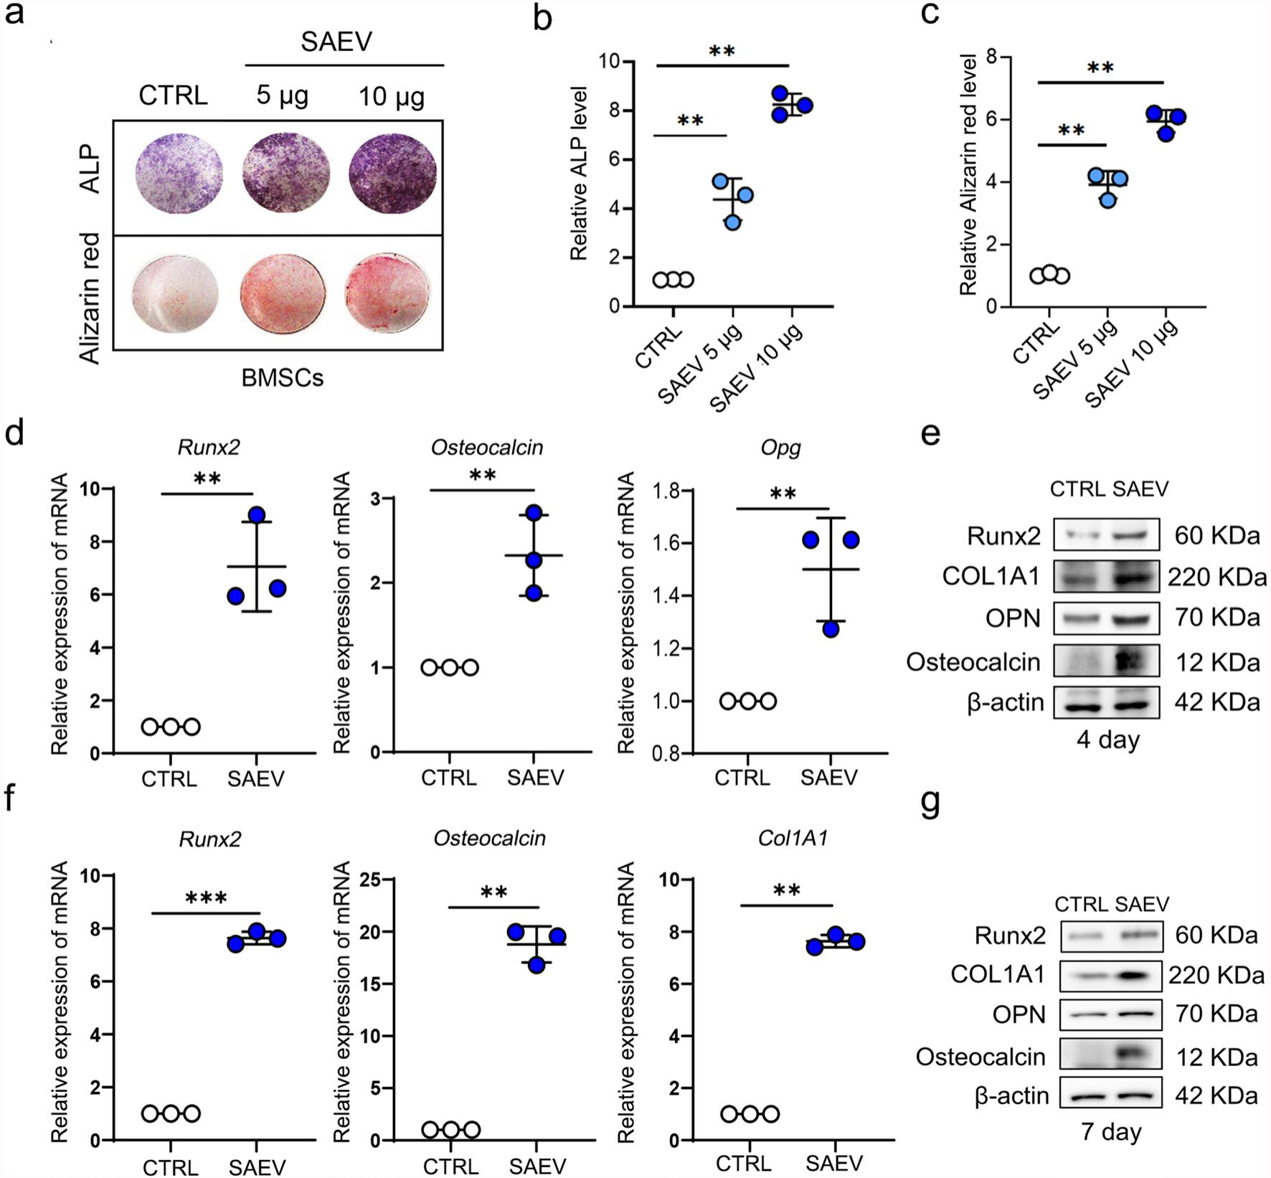
Fig. 4 SAEVs promote osteogenic differentiation. a Alkaline phosphate (ALP) and Alizarin Red S staining to visualize ALP activity and mineralization of BMSCs incubated with SAEVs for 7 days. b, c Relative ALP and Alizarin red staining levels were measured using Image J. d, f Quantitative reverse transcription-PCR (qRT-PCR) analysis to determine the mRNA expression levels of bone growth-related genes after treatment with SAEVs for 4 (d) and 7 days (f). e, g Western blotting was performed to compare the levels of bone growth-related proteins after treatment with SAEVs for 4 (e
full-length blots are presented in Additional file 7) and 7 days (g full-length blots are presented in Additional file 8). Data represent means ± SD, n = 3, **P < 0.01; ***P < 0.001. SAEV Sea buckthorn-derived extracellular vesicle

analyses demonstrated a binding interaction between LBH and aau–miR168 (Fig, 7c), To investigate the relation– ship between LBH, aau–miR168, and Runx2, a luciferase reporter assay was performed, The experiments entailed co–transfection of aau–miR168 and LBH with the Runx2 promoter, The results indicated that gradient transfection of LBH resulted in the inhibition of Runx2 transcriptional activity, Moreover, the introduction of aau–miR168 to the LBH group resulted in reversal of the transcriptional repression of Runx2 by LBH (Fig, 7d), Concurrently, the overexpression of aau–miR168 resulted in the inhibition of LBH expression (Fig, 7e), whereas the knockdown of

aau–miR168 led to the lifting of LBH inhibition (Fig, 7f), To investigate the role of LBH, we elevated LBH levels in BMSCs, PCR results revealed a significant upregulation of LBH expression in BMSCs (Fig, 7g), In addition, we observed that Runx2 was downregulated when LBH was overexpressed (Fig, 7h), Western blotting demonstrated that LBH overexpression primarily suppressed the upregu– lation of Runx2 induced by mimic–aau–miR168 (Fig, 7i and Additional file 10), To confirm that aau–miR168 enhances osteogenesis in BMSCs through the LBH/Runx2 path– way, we examined ALP activity and mineralization levels in BMSCs co–transfected with mimic–aau–miR168 and

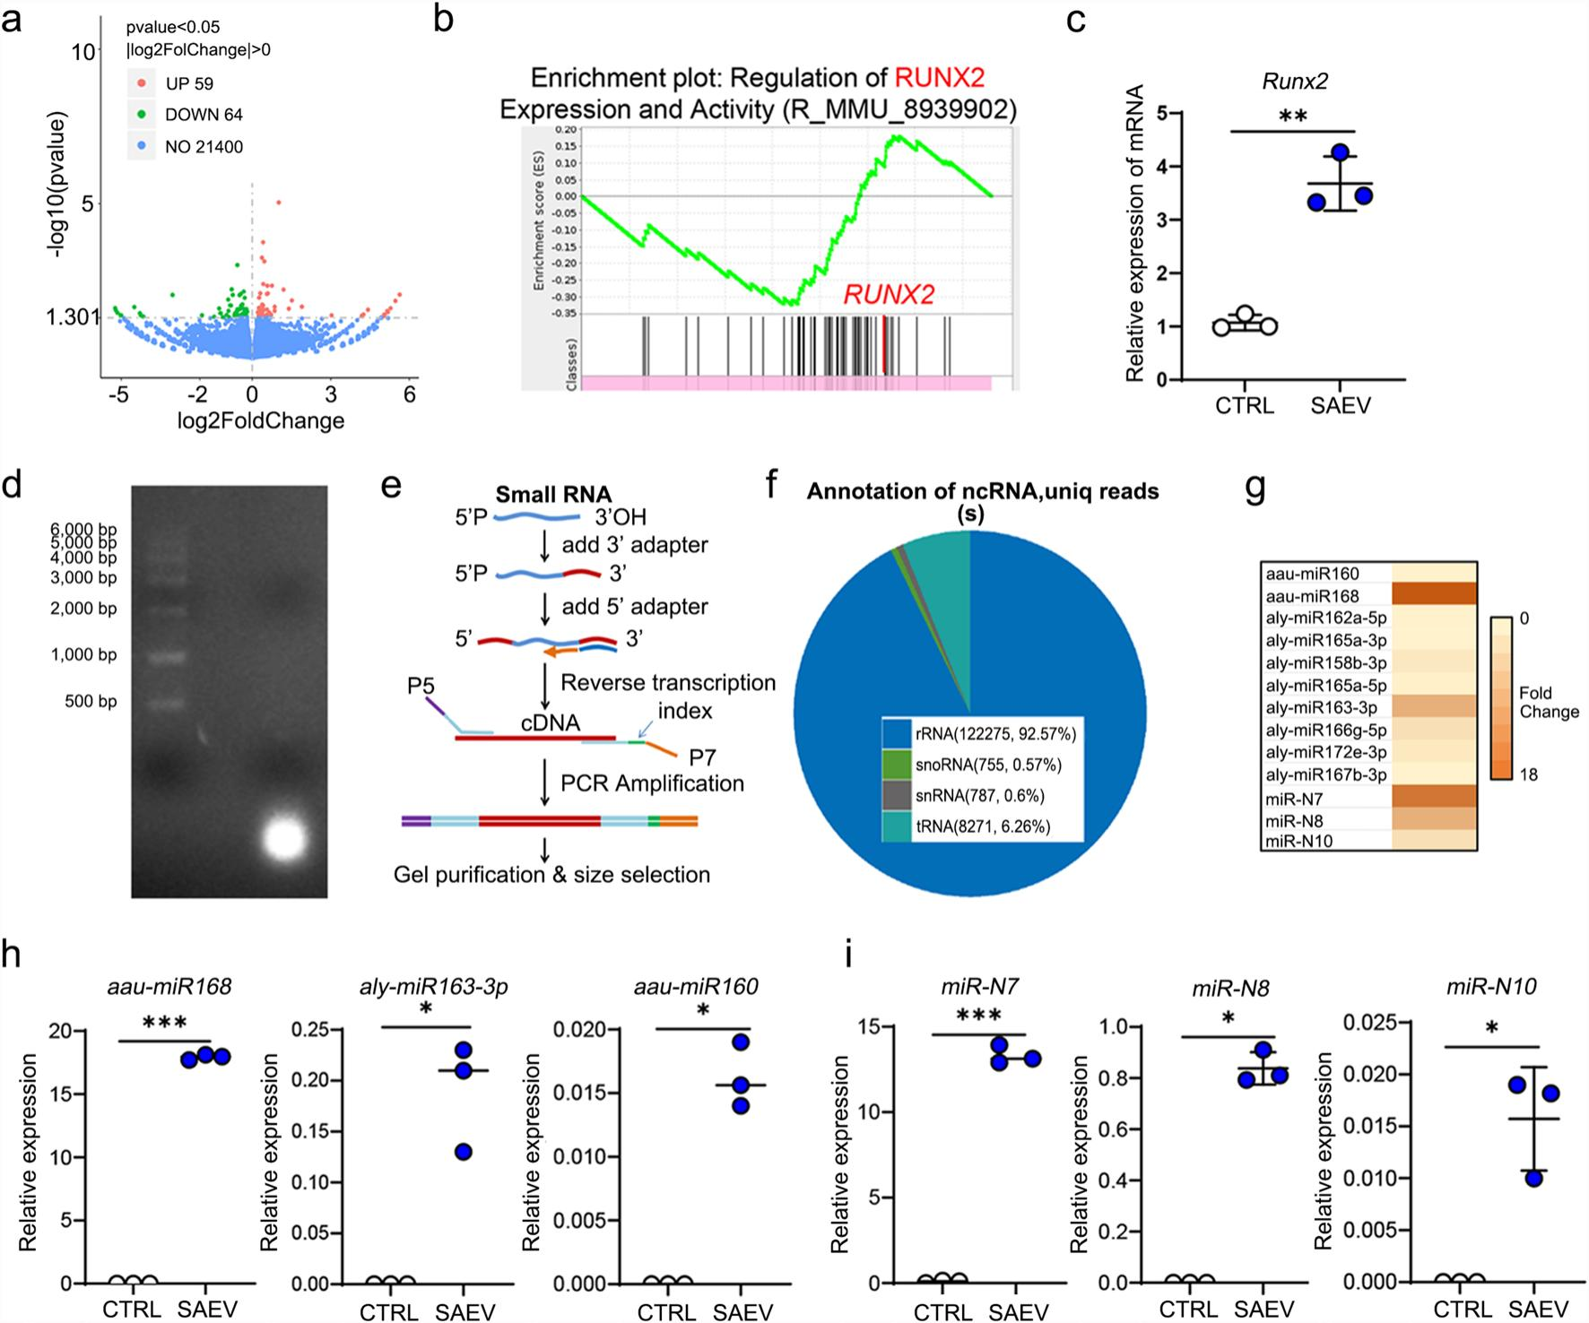
Fig. 5 SAEVs facilitate the upregulation of Runx2 contain multiple miRNAs. a The volcano plot illustrates the significant differences in gene
expression between BMSCs treated with SAEVs for 7 days and the control group, as revealed using RNA-seq. Red indicates genes upregulated
by SAEV treatment, green represents genes downregulated by SAEV treatment, and blue denotes genes with no significant difference in expression between the two groups. b Gene set enrichment analysis revealed the upregulation of RUNX2. c Quantitative reverse transcription-PCR (qRT-PCR) analysis to determine the mRNA expression levels of Runx2 following treatment with SAEVs for 7 days. d Agarose gel electrophoresis of RNA
extracted from SAEVs was performed using a 2% agarose gel to demonstrate the integrity and size distribution of RNA. e Flowchart of the small RNA library preparation. f Pie chart illustrating the percentage distribution of different non-coding RNAs (ncRNAs) in SAEVs. g Relative abundance of miRNAs in SAEVs. h qPCR analysis was performed to validate the relative expression of plant miRNAs extracted from the SAEVs. Data represent mean ± SD. *P < 0.05; ***P < 0.001. SAEV Sea buckthorn-derived extracellular vesicle

pCDH–FLAG–LBH after 4 days of osteogenic induction, The results demonstrated that the inhibitory effect of LBH on osteogenesis was reversed upon co–transfection and aau–miR168 enhanced the BMSC osteogenic capacity by suppressing LBH (Fig, 7j–l), In conclusion, aau–miR168 regulates the osteogenic differentiation of mesenchy– mal stromal cells through the LBH/Runx2 pathway,

Discussion
In this study, we successfully isolated SAEVs from fresh sea buckthorn pulp and demonstrated that they exhibit morphological and functional similarities to mammalian exosomes,

Specifically, SAEVs exhibited comparable sizes, a bilayer membrane structure identical to that of exosomes, and similar cellular uptake pathways, with time – and dose–dependent effects,
Recent studies support the notion that plant–derived EVs can improve bone health, For example, yam – derived exosome–like nanovesicles (YNVs) promote osteogenesis by activating the p38 MAPK pathway and may regulate osteogenic differentiation through the BMP2/p–p38–dependent Runx2 pathway, YNVs pro – mote bone formation and inhibit bone resorption [8], Similarly, ginseng–derived EVs inhibit osteoclast dif– ferentiation in lipopolysaccharide–induced bone–defect

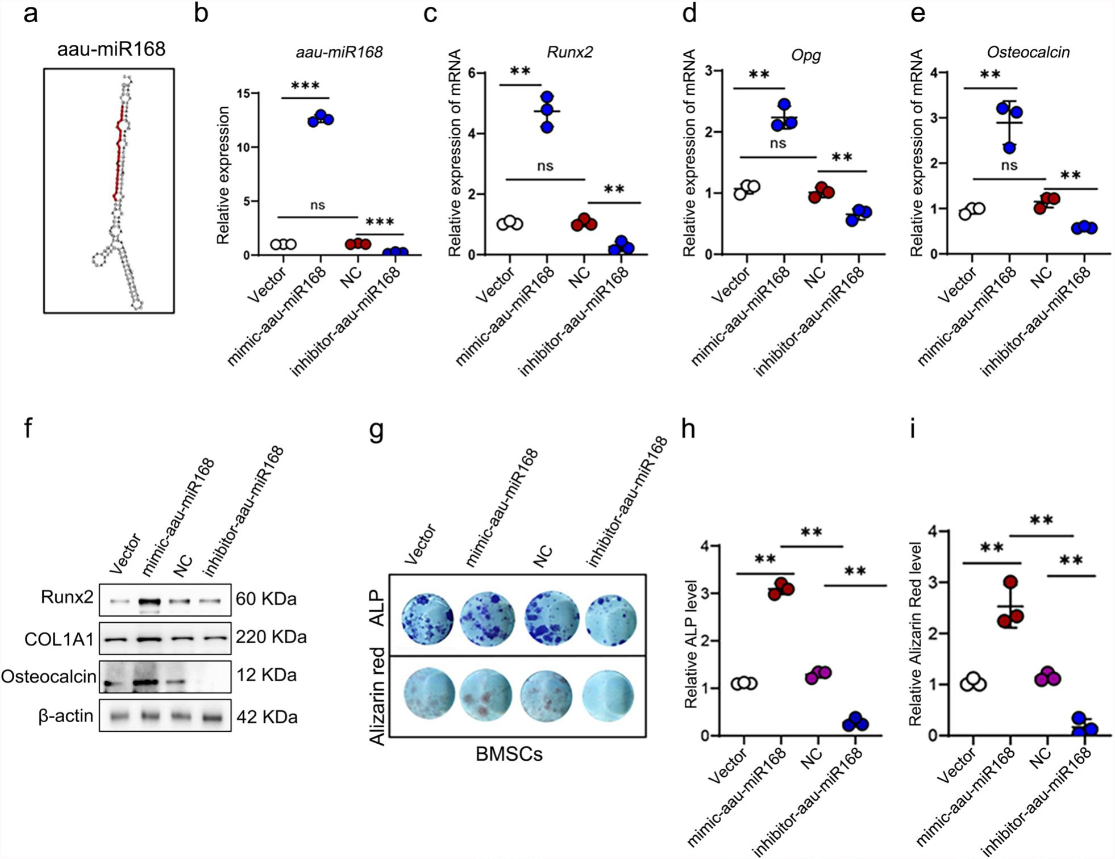
Fig. 6 aau-miR168 promotes osteogenic differentiation. a aau-miR168 structural prediction diagram. b Quantitative reverse transcription-PCR
(qRT-PCR) analysis of the relative expression levels of aau-miR168 in BMSCs following transfection with the aau-miR168 mimics and inhibitors.
c–e qPCR analysis of the relative expression levels of bone growth-related genes in BMSCs following transfection with aau-miR168 mimics
and inhibitors. f Western blotting was performed to compare the levels of bone growth-related proteins following treatment with aau-miR168
mimics and inhibitors. Full-length blots are presented in Additional file 9. g–h Alkaline phosphate (ALP) and Alizarin Red S staining to visualize ALP activity and mineralization of BMSCs incubated with aau-miR168 mimics and inhibitors for 7 days. The staining intensity was analyzed statistically using Image J. Data represent the mean ± SD. n = 3, **P < 0.01; ***P < 0.001. ALP Alkaline phosphatase, BMSC Bone marrow mesenchymal stromal cell

models, mitigating the upregulation of IκBα, JNK, and ERK induced by RANKL and M–CSF [32], Moreover, EVs derived from Cissus quadrangularis calli promote osteogenic differentiation in MC3 T3–E1 cells [33], Plant– derived EVs possess bone–targeting properties, reinforc– ing their potential use to treat bone diseases [34],
Nevertheless, there is limited research on the potential of plant–derived EVs in bone trauma repair, This study demonstrated that SAEVs exhibit promising effects on bone regeneration, The findings indicate that differen – tial centrifugation yields over 0,1 g of SAEVs from 100 g of sea buckthorn pulp, with the raw material cost of obtaining 1 g of SAEVs being less than 26 Chinese Yuan, Compared with stem cell–derived exosomes, SAEVs

offer substantial cost advantages, In addition, their reduced immunogenicity and toxicity [35] relative to animal–derived EVs enhances their suitability for clinical applications,
In this study, oral supplementation with SAEVs (1 mg/ kg) did not demonstrate a significant therapeutic effect, which can be attributed to several factors,
First, the dosage of the orally administered SAEVs may have been insufficient, A dosage of 1 mg/kg may not elicit a notable therapeutic effect, particularly when combined with localized treatment with SAEVs@GelMA, Furthermore, imaging results following oral administration indicated that SAEVs were primarily localized to the epiphyseal region of the femur, whereas the bone–defect model was situated in

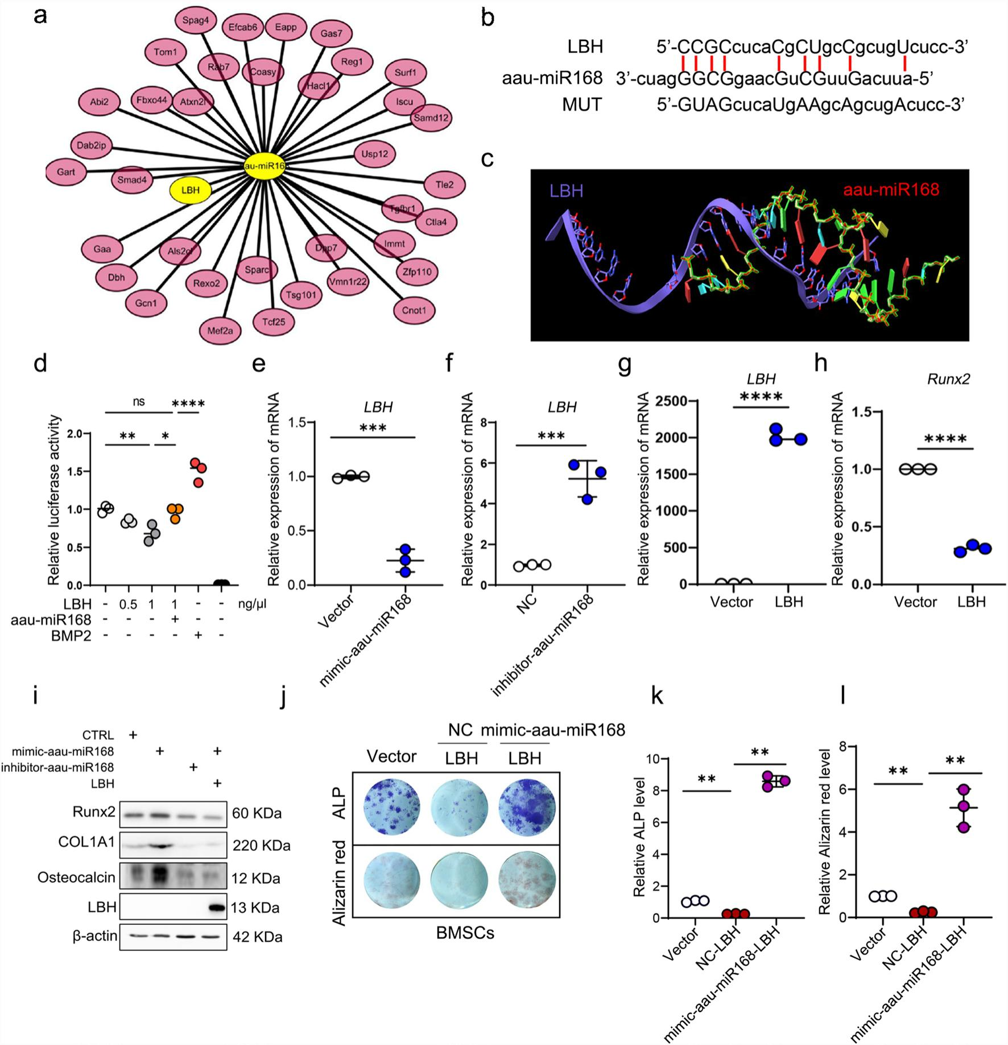
Fig. 7 LBH regulates osteogenic differentiation as a target gene of aau-miR168. aThe miRNA-target gene network diagram for aau-miR168
illustrates the relationships between the miRNA and its target genes, with line length indicating the strength of the correlation; shorter lines signify stronger correlations. b Prediction of a nucleotide sequence complementary to aau-miR168 within the LBH gene sequence. c Structural prediction diagram of the binding site between LBH and aau-miR168. d Luciferase reporter assay demonstrating the inhibitory effect of LBH on Runx2
promoter activity and the reversal of this repression by aau-miR168 co-transfection. e, f Quantitative reverse transcription-PCR (qRT-PCR) analysis
of the relative expression levels of LBH in BMSCs following transfection with aau-miR168 mimics (e) and inhibitors (f). g, h qPCR analysis of relative expression levels of LBH (g) and Runx2 (h) in BMSCs overexpressing LBH. i Western blot analysis showing the differential expression of bone
growth-related proteins under various conditions, including miR168 mimics or inhibitors and co-incubation of mimics with LBH overexpression.
Full-length blots are presented in Additional file 10. j ALP and Alizarin Red S staining to visualize ALP activity and mineralization of BMSCs incubated with mimics-aau-miR168 with or without LBH overexpression for 4 d. k–l ALP and Alizarin Red S staining to visualize ALP activity and mineralization of BMSCs incubated with aau-miR168 mimics with or without LBH overexpression for 7 days. Relative ALP level and relative Alizarin Red level
of staining were measured by Image J. Data represent the mean ± SD. n = 3, **P < 0.01; ***P < 0.001. ALP Alkaline phosphatase, BMSC Bone marrow mesenchymal stromal cell, SAEV Sea buckthorn-derived extracellular vesicle, ALP Alkaline phosphate

the midshaft of the femur, This indicates that orally admin– istered SAEVs might not have reached the defect site effec– tively via circulation, However, as the epiphyseal region

was not scanned during the micro–CT analysis, comparing the differences in the bone trabecular structure between the groups is not yet possible, In future studies, we intend

to examine the efficacy of oral SAEVs by comparing bone regeneration at the defect site and trabecular parameters in cancellous bone between different doses of SAEVs and the Sham group,
At the 28–day mark, the therapeutic effects of SAEVs did not demonstrate notable improvement compared with that of the control group, This may be attributed to the exhaus– tion of SAEVs released from the GelMA hydrogel, which seemed to reach saturation by day 16, Consequently, the acceleration of bone regeneration driven by SAEVs might have been exhausted by day 14, limiting its effect by day 28,
Given the bone–targeting properties of SAEVs, future studies should investigate their potential as nanocarriers for drug delivery to enhance targeting and therapeutic efficacy, miRNAs and SAEVs contain various peptides, Given the time constraints, this aspect has not yet been fully explored, In subsequent studies, we will conduct a more comprehen– sive investigation of these peptide components,

Conclusions
The findings of this study show that aau–miR168 from SAEVs promotes the osteogenic differentiation of BMSCs and bone regeneration by modulating the LBH/Runx2 pathway, This study has some limitations, For instance, the potential roles of polypeptides and lipids in SAEVs have not been discussed, and the impact of SAEVs on osteoclast activity has not been addressed, Nevertheless, this research provides evidence that plant–derived EVs can regulate mam– malian stem cell differentiation via miRNAs, thus offering new perspectives for developing therapeutic applications in bone regeneration,
Abbreviations
ALP Alkaline phosphatase DiD DiD perchlorate
BMSC Bone marrow mesenchymal stromal cell
EIPA Ethylisopropylamiloride
GelMA Gelatin methacryloyl
CT Computed tomography BV/TV Bone volume density
Tb. N Trabecular number
Tb. Sp Trabecular separation
Tb. Th Trabecular thickness
EVs Extracellular vesicles
H&E Hematoxylin and eosin IVIS In vivo imaging system OM Osteogenic medium IP Immunoprecipitation
SAEV Sea buckthorn-derived extracellular vesicle
YNV Yam-derived exosome-like nanovesicle
Supplementary Information
The online version contains supplementary material available at https://doi. org/10.1186/s13287-025-04373-8.
Additional file 1
Additional file 2
Additional file 3

Acknowledgements
The authors would like to express their gratitude to Prof. Lingli Zhang of the Scientific Research Department at Shanghai University of Sport for her invalu- able assistance with the micro CT scan and Dr. Ping Li of the Bio-X Research Institute at Shanghai Jiao Tong University for her contributions to the micro CT analysis. English language editing was provided by Editage (www.edita
ge.cn). The authors declare that they have not use AI-generated work in this manuscript.
Author contributions
Hao Jia, Haodong Lin, and Zhaoyuan Hou conceived and designed the study. Mai Zhao and Xiaolin Chen performed the experiments and generated
data. Wenyan Wang, Mengying Li, Hui Zhang, and Xiuqun Zou assisted with the experiments. Jiamin Wang provided critical reagents. Hao Jia, Haodong Lin, and Zhaoyuan Hou wrote the manuscript. Qian Cong and Xingyuan
Ma helped revise the manuscript. All authors reviewed and approved the manuscript.
Funding
This study was supported by the Natural Science Foundation of Shanghai
Municipality (24ZR1441300), the Shanghai Oriental Talents Program (2023DFY- CJH), the Natural Science Foundation of Shandong Province (ZR2021ZD16),
and the High-level Innovative Research Team of Local Universities of Shanghai Municipality (SHSMU-ZDCX20211801).
Availability of data and materials
The datasets used and/or analyzed during the current study are available from the corresponding author upon reasonable request. The raw sequence data reported in this paper have been deposited in the Genome Sequence Archive (Genomics, Proteomics & Bioinformatics 2021) in National Genomics Data
Center (Nucleic Acids Res 2022), China National Center for Bioinformation/
Beijing Institute of Genomics, Chinese Academy of Sciences (GSA: CRA021988) that are publicly accessible at https://ngdc.cncb.ac.cn/gsa. The data will be
released to the public when the paper is published.

Declarations
Ethics approval and consent to participate
The animal experiments were conducted following the ARRIVE guidelines
2.0 (Animal Research: Reporting of In Vivo Experiments). All animal experi-
ments were conducted in accordance with the guidelines set forth by the
Institutional Animal Care and Use Committee of Shanghai (Shanghai, China) and in compliance with the National Research Council (Beijing, China) Guide for the Care and Use of Laboratory Animals (SCXK) (Shanghai 2007–0005).
The research project was approved“Fate-Determining Mechanisms ofAJUBA Promoting Differentiation of Mesenchymal Stem Cells Toward Osteogenesis through Phosphorylation of STAT5”(Approval number, 31970679. Date of
approval, 2020.1.1.NSF).
Consent for publication
Not applicable. No individual person’s data is included in this publication.
Competing interests
The authors declare that they have no competing interests.
Author details
1Trauma Center, Shanghai General Hospital, Shanghai Jiao Tong University
School of Medicine, New Songjiang Road 650, Shanghai 201620, China. 2 Fac- ulty of Basic Medicine, Shanghai Jiao Tong University School of Medicine, 280 South Chongqing Road, Shanghai 200025, China. 3Shanghai Key Laboratory for Tumor Microenvironment and Inflammation, Department of Biochemistry and Molecular Cellular Biology, Shanghai Jiao Tong University School of Medi- cine, Shanghai 200025, China. 4 Department of Biomedical Sciences, College of Dentistry, Texas A&M University, 3302 Gaston Avenue, Room 455, Dallas,
TX 75246, USA. 5State Key Laboratory of Bioreactor Engineering, East China University of Science and Technology, Shanghai 200237, China.
Received: 17 December 2024 Accepted: 2 May 2025

published online:03June2025

References
1. Dimitriou R, Jones E, McGonagle D, Giannoudis PV. Bone regeneration: cur- rent concepts and future directions. BMC Med. 2011;9:66.
2. El-Rashidy AA, Roether JA, Harhaus L, Kneser U, Boccaccini AR. Regenerat- ing bone with bioactive glass scaffolds: a review of in vivo studies in bone defect models. Acta Biomater. 2017;62:1–28.
3. Cao M, Diao N, Cai X, Chen X, Xiao Y, Guo C, et al. Plant exosome nanovesi- cles (PENs): green delivery platforms. Mater Horiz. 2023;10:3879–94.
4. Wang B, Zhuang X, Deng ZB, Jiang H, Mu J, Wang Q, et al. Targeted drug
delivery to intestinal macrophages by bioactive nanovesicles released from grapefruit. MolTher. 2014;22:522–34.
5. Castelli G, Logozzi M, Mizzoni D, Di Raimo R, Cerio A, DoloV, et al. Ex vivo anti-leukemic effect of exosome-like grapefruit-derived nanovesicles
from organic farming—the potential role of ascorbic acid. Int J Mol Sci. 2023;24:15663.
6. Zhou X, Xu S, Zhang Z, Tang M, Meng Z, Peng Z, et al. Gouqi-derived
nanovesicles (GqDNVs) inhibited dexamethasone-induced muscle atrophy associating with AMPK/SIRT1/PGC1α signaling pathway. J Nanobiotechnol. 2024;22:276.
7. Wang F, Yuan M, Shao C, Ji N, Zhang H, Li C. Momordica charantia-derived extracellular vesicles provide antioxidant protection in ulcerative colitis. Molecules. 2023;28:6182.
8. Hwang J-H, Park Y-S, Kim H-S, Kim D-H, Lee S-H, Lee C-H, et al. Yam-derived exosome-like nanovesicles stimulate osteoblast formation and prevent
osteoporosis in mice. J Control Release. 2023;355:184–98.
9. Dad HA, GuTW, Zhu AQ, Huang LQ, Peng LH. Plant exosome-like nanovesi- cles: emerging therapeutics and drug delivery nanoplatforms. MolTher.
2021;29:13–31.
10. Ling N, Tian H, Wang Q, Gao M, Xu G, SunY, et al. Advance in Hippophae
rhamnoides polysaccharides: extraction, structural characteristics, pharma- cological activity, structure-activity relationship and application. Int J Biol Macromol. 2024;270:132420.
11. Xu X, Liu X, Yu S, Wang T, Li R, Zhang Y, et al. Medicinal and edible polysac- charides from ancient plants: extraction, isolation, purification, structure, biological activity and market trends of sea buckthorn polysaccharides. Food Funct. 2024;15:4703–23.
12. Wang Z, Zhao F, Wei P, Chai X, Hou G, Meng Q. Phytochemistry, health
benefits, and food applications of sea buckthorn (Hippophae rhamnoides L.): a comprehensive review. Front Nutr. 2022;9:1036295.
13. Yuan M, Chang L, Gao P, Li J, Lu X, Hua M, et al. Synbiotics containing sea
buckthorn polysaccharides ameliorate DSS-induced colitis in mice via regu- lating Th17/Treg homeostasis through intestinal microbiota and their pro- duction of BA metabolites and SCFAs. Int J Biol Macromol. 2024;276:133794.
14. Yan Z, Feng X, Li X, Gao Z, Wang Z, Ren G, Long F. Sea buckthorn flavonoid extracted by high hydrostatic pressure inhibited IgE-stimulated mast cell
activation through the mitogen-activated protein kinase signaling pathway. Foods. 2024;13:560.
15. Hua Z, Zhang J, Cheng W, Wang C, Zhao D. Ethanolic extract from seed
residues of sea buckthorn (Hippophae rhamnoides L.) ameliorates oxidative stress damage and prevents apoptosis in murine cell and aging animal
models. Foods. 2023;12:3322.
16. Gu MJ, Lee HW, Yoo G, Kim D, Kim Y, Choi IW, et al. Hippophae rhamnoides
L. leaf extracts alleviate diabetic nephropathy via attenuation of advanced glycation end product-induced oxidative stress in db/db mice. Food Funct. 2023;14:8396–408.
17. Liu X, XingY, Yuen M, YuenT, Yuen H, Peng Q. Anti-aging effect and mecha- nism of proanthocyanidins extracted from sea buckthorn on hydrogen
peroxide-induced aging human skin fibroblasts. Antioxidants (Basel). 2022;11:1900.
18. Ye L, Ma RH, Zhang XX, Thakur K, Zhang JG, Khan MR, et al. Isorhamnetin
induces apoptosis and suppresses metastasis of human endometrial carci- noma Ishikawa cells via endoplasmic reticulum stress promotion and matrix Metalloproteinase-2/9 inhibition in vitro and in vivo. Foods. 2022;11:3415.
19. Batbold U, Liu JJ. Chemosensitization effect of seabuckthorn (Hippophae
rhamnoides L.) pulp oil via autophagy and senescence in NSCLC cells. Foods. 2022;11:1517.
20. Al Ibrahim M, Akissi ZLE, Desmarets L, Lefèvre G, Samaillie J, Raczkiewicz I, et al. Discovery of anti-coronavirus cinnamoyl triterpenoids isolated from Hippophaerhamnoides during a screening of halophytes from the North Sea and channel coasts in Northern France. Int J Mol Sci. 2023;24:16617.

21. Huan C, Xu Y, Zhang W, Pan H, Zhou Z, Yao J, et al. Hippophaerhamnoides polysaccharides dampen pseudorabies virus infection through down- regulating adsorption, entry and oxidative stress. Int J Biol Macromol.
2022;207:454–63.
22. Yuan L, Zhang W, Fang W, Zhuang X, Gong W, Xu X, et al. Sea buckthorn
polyphenols alleviate high-fat-diet-induced metabolic disorders in mice via reprograming hepatic lipid homeostasis owing to directly targeting fatty
acid synthase. J Agric Food Chem. 2024;72:8632–49.
23. Shen F, Zhuang J, Wang Q, Zhang J, Huang Y, Mo Q, et al. Enhancement in the metabolic profile of sea buckthorn juice via fermentation for its better efficacy on attenuating diet-induced metabolic syndrome by targeting gut microbiota. Food Res Int. 2022;162:111948.
24. Xia CX, Gao AX, Dong TTX, Tsim KWK. Flavonoids from Seabuckthorn (Hip- pophae rhamnoides L.) mimic neurotrophic functions in inducing neurite outgrowth in cultured neurons: signaling via PI3K/Akt and ERK pathways. Phytomedicine. 2023;115:154832.
25. Zhu X, Cai L, Liu J, Zhu W, Cui C, Ouyang D, et al. Effect of seabuckthorn seed protein and its arginine-enriched peptides on combating memory impair- ment in mice. Int J Biol Macromol. 2023;232:123409.
26. Zhou W, Ouyang J, Hu N, Wang H. Flavonoids from Hippophaerhamnoides Linn. revert doxorubicin-induced cardiotoxicity through inhibition of
mitochondrial dysfunction in H9c2 cardiomyoblasts in vitro. Int J Mol Sci. 2023;24:3174.
27. Lee DE, Park KH, Hong JH, Kim SH, Park KM, Kim KH. Anti-osteoporosis
effects oftriterpenoids from the fruit of sea buckthorn (Hippophae rham- noides) through the promotion of osteoblast differentiation in mesenchy- mal stem cells, C3H10T1/2. Arch Pharm Res. 2023;46:771–81.
28. Lee YH, Jang HJ, Park KH, Kim SH, Kim JK, Kim JC, et al. Phytochemical
analysis of the fruits of sea buckthorn (Hippophae rhamnoides): identification of organic acid derivatives. Plants (Basel). 2021;10:860.
29. YuanYF, Wang S, Zhou H, Tang BB, Liu Y, Huang H, et al. Exploratory study of sea buckthorn enhancing QiangGuYin efficacy by inhibiting CKIP-1 and Notum activating the Wnt/beta-catenin signaling pathway and analysis of active ingredients by molecular docking. Front Pharmacol. 2022;13:994995.
30. Zhao J, Zhu W, Mao Y, Li X, Ling G, Luo C, et al. Unignored intracellular jour- ney and biomedical applications of extracellular vesicles. Adv Drug Deliv Rev. 2024;212:115388.
31. Zhu F, Wang T, Wang G, Yan C, He B, Qiao B. The exosome-mediated bone regeneration: an advanced horizon toward the isolation, engineering, carry- ing modalities, and mechanisms. Adv Healthc Mater. 2024;13:e2400293.
32. Seo K, Yoo JH, Kim J, Min SJ, Heo DN, Kwon IK, et al. Ginseng-derived
exosome-like nanovesicles extracted by sucrose gradient ultracentrifuga- tion to inhibit osteoclast differentiation. Nanoscale. 2023;15:5798–808.
33. Gupta R, Gupta S, Gupta P, Nüssler AK, Kumar A. Establishing the callus-
based isolation of extracellular vesicles from Cissus quadrangularis and eluci- dating their role in osteogenic differentiation. J Funct Biomater. 2023;14:540.
34. Zeng YB, Deng X, Shen LS, Yang Y, Zhou X, Ye L, et al. Advances in plant- derived extracellular vesicles: isolation, composition, and biological func- tions. Food Funct. 2024;15:11319–41.
35. Ou X, Wang H, Tie H, Liao J, Luo Y, Huang W, et al. Novel plant-derived
exosome-like nanovesicles from Catharanthus roseus: preparation, char- acterization, and immunostimulatory effect via TNF-α/NF-κB/PU.1 axis. J Nanobiotechnol. 2023;21:160.
Publisher’s Note
Springer Nature remains neutral with regard to jurisdictional claims in published maps and institutional affiliations.

